**Discovery Park Online Apartment Rental Management System**

INFO 5707: Term Project Proposal

**Team Members:**

Sai Satish Pallapolu

**Objective:**

The Discovery Park Online Apartment Rental Management System provides a digital tool for apartment rental processes with improvements for efficiency along with better user experiences. The platform functions as a single database through which property owners, tenants and administrators can execute rental contract management tasks combined with property availability functions and facility request systems and financial process handling.

**Scope:**

* This application facilitates online property listings and rental management like payments and maintenance.
* This database performs complete lease management functions that include agreement end dates and rent amount.
* This database maintains rental payment records track and status.
* The database supports the handling of maintenance requests which also includes monitoring service completion statuses.
* This database is supported by multi-user access with role-based privileges which means multiple users can access and perform operations like public and administrators.
* This database system protects data security through PostgreSQL ACID compliance combined with role-based access control features which means features are shown or will be enabled as per the login user.
* This database system enables usage by users from different language backgrounds and those who require currency conversion capabilities.

**User requirements that the system will be able to address:**

1. This database system provides capabilities for landowners to publish their property listings along with images and descriptions of property.
2. This database platform grants tenants a system to find the property listed listings and displays the rental application documentation.
3. This system provides payment processing functionality that enables tenants to pay rent online and owners can track of payments pending transactions status.
4. This allows tenants to file service requests system automatically assigns available technician.
5. This system implements the features for secure user logins and shows certain pages to users.
6. Tenants can know their neighbours present in the community by a feature know your community.
7. A super admin can onboard a tenant, owner or other managers to access database as per their roles and privileges.
8. This database system provides different roles for landlords and managers and tenants. This includes three different user groups to interact with the system.
9. Manager can onboard technicians to assign service request based on their availability.
10. Technicians can update their status availability as per their availability also system does not assign to technicians who are not available.

**Business rules:**

The following are the business rules enforced by the database system

1. For each property there will be only one property owner, and an owner can hold many properties.
2. For each property there will be only one tenant, and one tenant can rent only one property at a time under his name.

(To achieve tenant_email field is added with a constraint UNIQUE, which does not allow a tenant to get added to other property at a time until they are unassigned to a property).

1. For each property there can be one and only manager assigned.
2. Each tenant must have one and only one property.

(This is achieved by making a property number in tenant table as unique)

1. An Owner or Manager must cannot exist without a property. (This is achieved by making property as not null when inserting a record. A property owner can have one or more tenants.
2. Each lease file will be associated with only one property and one lease file should dedicated to one and only property. This is achieved by making the property_id UNIQUE, so that one property_id have only one lease file on it)
3. One Property can have only one listing at a time. (Since property id is set to primary this results in unique constraint)
4. Each payment will refer to one and only one property and payments are made to a valid house number which is property_id in property table.

(For every payment a transaction reference is generated which starts with TX and yyyymm and current year and month followed by property number and a random 3-digit suffix.)

(For every payment a payment id is generated with a random 5-digit number followed by a hyphen and a 2 random number digit number.)

1. For every service request created systems generates a new unique service request starts with SRYYYYMMDD + property number + sequence number (starting from 1001 to 9999). meaning starts with a text SR followed by current year, date and month YYYYMMDD and property number for which it is raised and a random 4-digit sequence.
2. There will be only one technician associated with a service request.
3. Status of a service request will be open by default when created unless it is updated by a technician. (Only a technician can update service request).
4. Each Property has a unique “property_id” field, which is referred by payments, lease file and service request. (Every payment ,lease_file ,service request are bound by a property_id).
5. A tenant must have a lease agreement associated with the property to make a payment on rent. (Since rent amount is decided with lease).

**ERD Diagram:**

The below diagram shows the ERD representation of the tables given

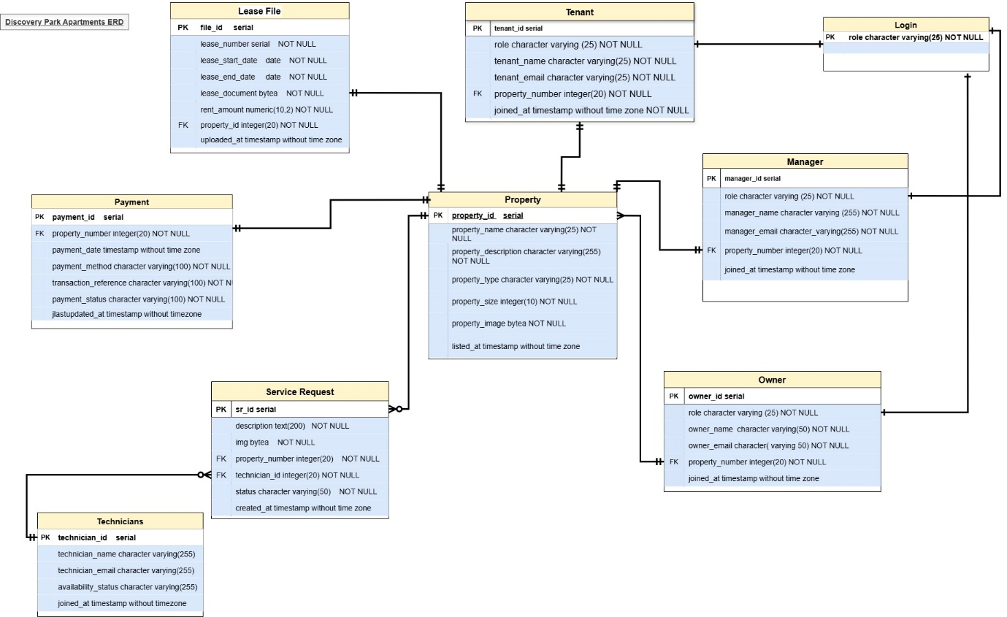

**Data Dictionary:**

The below diagram shows the Data Dictionary representation of the tables given

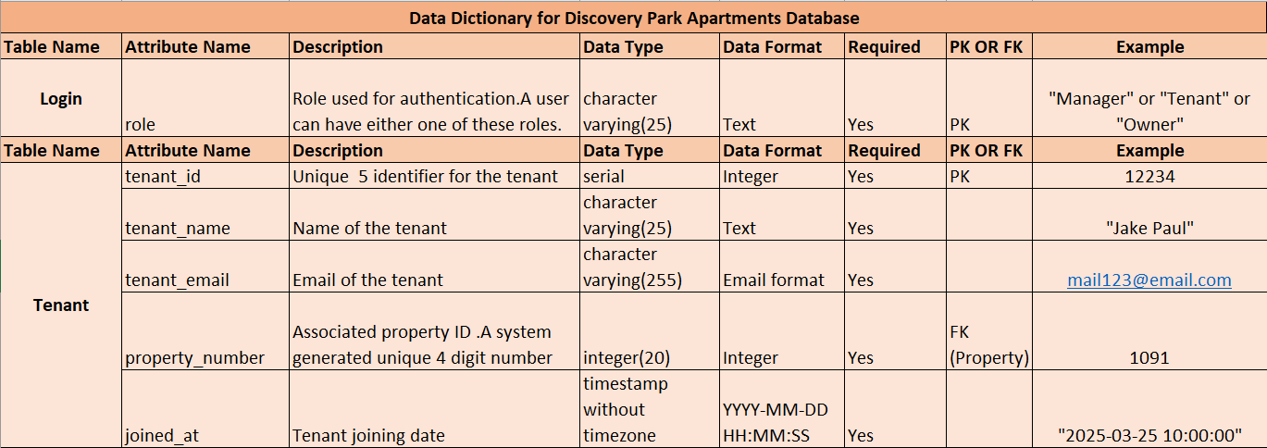

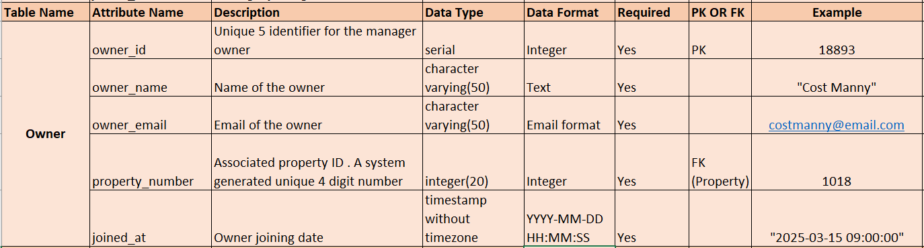

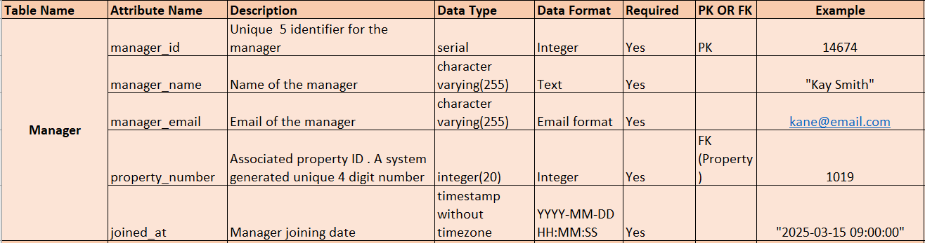

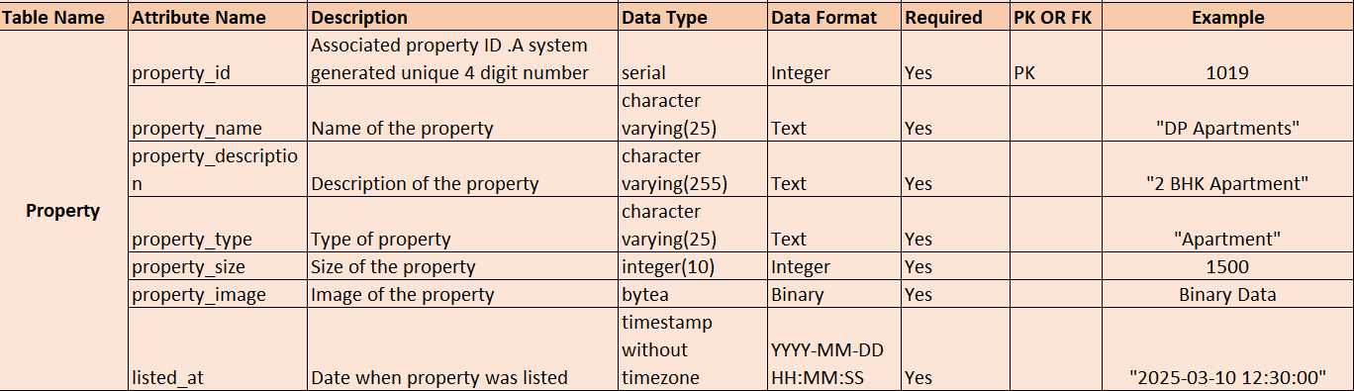

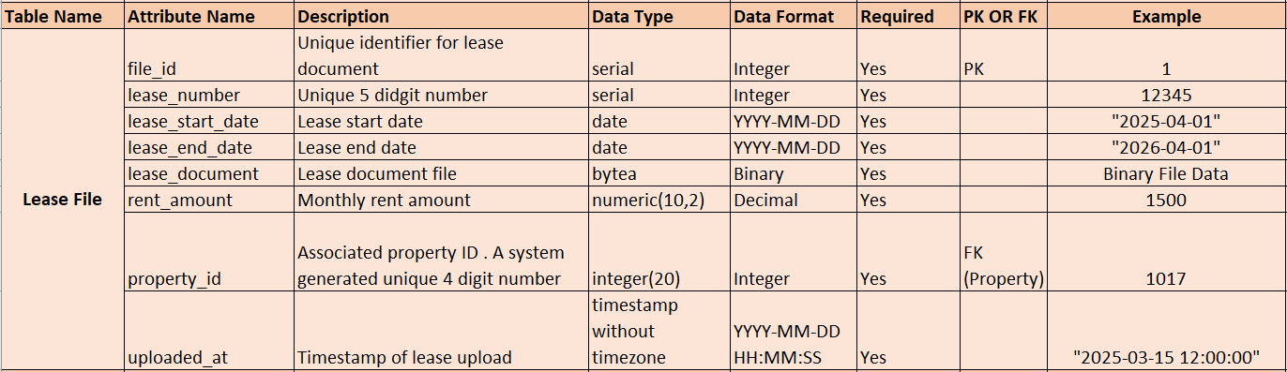

|  |
| --- |
|  |

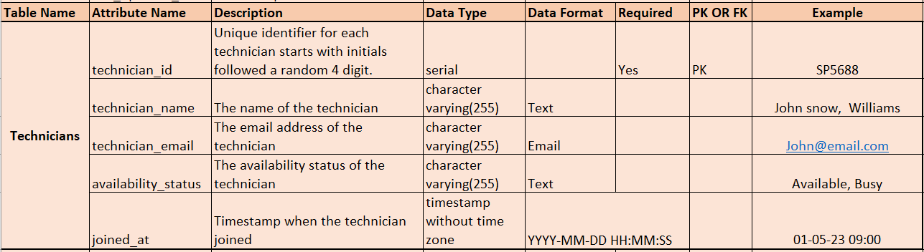

# Entity Generation and Data Entry:

An SQL sequence named property_property_id_seq is generated first and later “property” table is created with linking sequence with the table and later records are inserted into it.Below are the scripts.

**SQL Sequence Script –** Property

CREATE SEQUENCE property_property_id_seq START WITH 1001 INCREMENT BY 10 MINVALUE 1001 MAXVALUE 9999 CACHE 1;

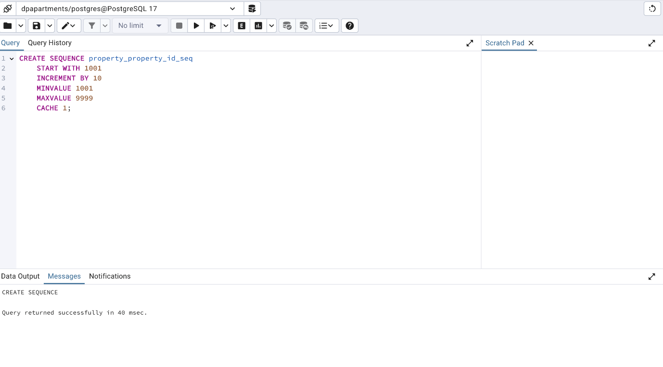**SQL Create Table –** Property

CREATE TABLE public.property ( property_id INTEGER PRIMARY KEY DEFAULT nextval('property_property_id_seq'), property_name VARCHAR(25) NOT NULL, property_description VARCHAR(255) NOT NULL, property_type VARCHAR(25) NOT NULL, property_size INT NOT NULL, property_image BYTEA NOT NULL, joined_at TIMESTAMP DEFAULT CURRENT_TIMESTAMP );

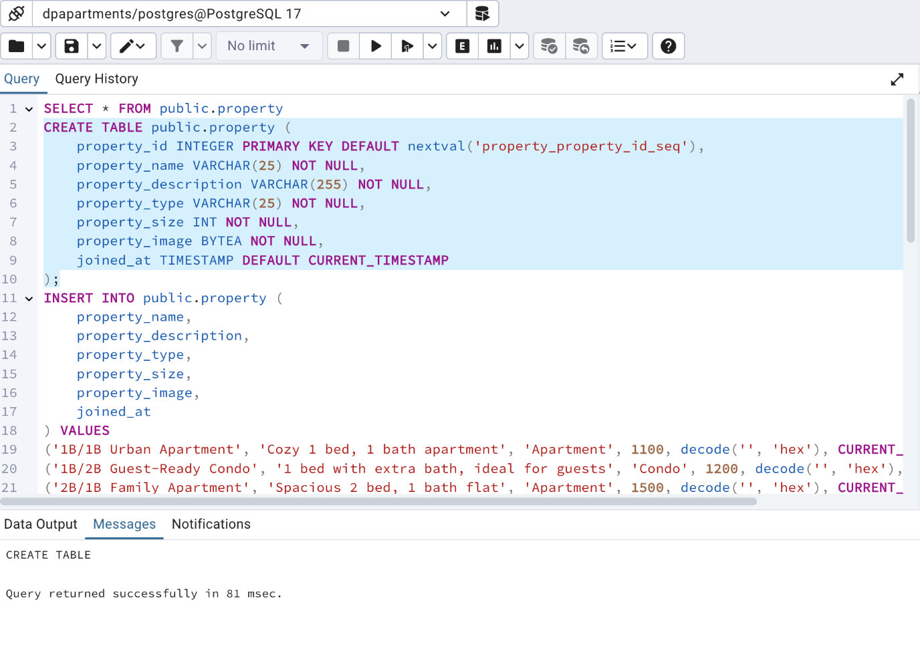**SQL Insert Table –** Property

INSERT INTO public.property (

property_name,

property_description,

property_type,

property_size,

property_image,

joined_at

) VALUES

('1B/1B Urban Apartment', 'Cozy 1 bed, 1 bath apartment', 'Apartment', 1100, decode('', 'hex'), CURRENT_TIMESTAMP),

('1B/2B Guest-Ready Condo', '1 bed with extra bath, ideal for guests', 'Condo', 1200, decode('', 'hex'), CURRENT_TIMESTAMP),

('2B/1B Family Apartment', 'Spacious 2 bed, 1 bath flat', 'Apartment', 1500, decode('', 'hex'), CURRENT_TIMESTAMP),

('2B/2B Modern Condo', 'Comfortable 2 bed, 2 bath condo', 'Condo', 1600, decode('', 'hex'), CURRENT_TIMESTAMP),

('2B/3B Spacious House', 'Family home with 2 bed, 3 baths', 'House', 1900, decode('', 'hex'), CURRENT_TIMESTAMP),

('3B/1B Starter Home', 'Three bed, single bath home', 'House', 2000, decode('', 'hex'), CURRENT_TIMESTAMP),

('3B/2B Townhouse Retreat', 'Modern 3 bed, 2 bath townhouse', 'Townhouse', 2200, decode('', 'hex'), CURRENT_TIMESTAMP),

('3B/3B Elegant Duplex', 'Stylish 3 bed, 3 bath duplex', 'Duplex', 2500, decode('', 'hex'), CURRENT_TIMESTAMP),

('3B/4B Luxury Villa', 'Luxury 3 bed, 4 bath villa', 'Villa', 2800, decode('', 'hex'), CURRENT_TIMESTAMP),

('4B/1B Budget House', '4 bedrooms with shared bath', 'House', 3000, decode('', 'hex'), CURRENT_TIMESTAMP),

('4B/2B Suburban Home', 'Spacious 4 bed, 2 bath home', 'House', 3200, decode('', 'hex'), CURRENT_TIMESTAMP),

('4B/3B Family Residence', 'Family 4 bed, 3 bath residence', 'House', 3500, decode('', 'hex'), CURRENT_TIMESTAMP),

('4B/4B Executive Villa', 'Premium 4 bed, 4 bath house', 'Villa', 3700, decode('', 'hex'), CURRENT_TIMESTAMP),

('1B/1B Urban Apartment', '1 bed retreat with garden view', 'Apartment', 1050, decode('', 'hex'), CURRENT_TIMESTAMP),

('2B/2B Modern Condo', 'Corner unit with 2 bed and 2 bath', 'Condo', 1700, decode('', 'hex'), CURRENT_TIMESTAMP),

('3B/2B Townhouse Retreat', 'Stylish layout with 3 bed, 2 bath', 'Townhouse', 2400, decode('', 'hex'), CURRENT_TIMESTAMP),

('2B/1B Family Apartment', 'Minimalist 2 bed flat', 'Apartment', 1400, decode('', 'hex'), CURRENT_TIMESTAMP),

('3B/3B Elegant Duplex', 'Bright and airy 3 bed, 3 bath', 'House', 2700, decode('', 'hex'), CURRENT_TIMESTAMP),

('4B/4B Executive Villa', 'Elite 4 bed home with pool', 'Villa', 4000, decode('', 'hex'), CURRENT_TIMESTAMP),

('1B/2B Guest-Ready Condo', 'Unique 1 bed unit with dual baths', 'Condo', 1300, decode('', 'hex'), CURRENT_TIMESTAMP),

('2B/3B Spacious House', 'Entertainer’s dream home', 'Townhouse', 1850, decode('', 'hex'), CURRENT_TIMESTAMP),

('3B/1B Starter Home', 'Budget-friendly 3 bed flat', 'Apartment', 1950, decode('', 'hex'), CURRENT_TIMESTAMP),

('4B/1B Budget House', 'Roomy 4 bed with single bath', 'House', 3100, decode('', 'hex'), CURRENT_TIMESTAMP),

('3B/2B Townhouse Retreat', 'Open-plan 3 bed layout', 'Duplex', 2300, decode('', 'hex'), CURRENT_TIMESTAMP),

('1B/1B Urban Apartment', 'City studio with 1 bed and bath', 'Apartment', 1025, decode('', 'hex'), CURRENT_TIMESTAMP),

('4B/3B Family Residence', 'Three bath home, great for families', 'House', 3600, decode('', 'hex'), CURRENT_TIMESTAMP),

('2B/2B Modern Condo', 'Balanced living in 2 bed condo', 'Condo', 1750, decode('', 'hex'), CURRENT_TIMESTAMP),

('3B/4B Luxury Villa', 'Modern luxury with 4 baths', 'Villa', 2900, decode('', 'hex'), CURRENT_TIMESTAMP),

('4B/2B Suburban Home', 'Convenient 4 bed home near park', 'House', 3300, decode('', 'hex'), CURRENT_TIMESTAMP),

('4B/4B Executive Villa', 'Top-tier 4 bed luxury estate', 'Villa', 7000, decode('', 'hex'), CURRENT_TIMESTAMP),

('Studio Apartment', 'Modern studio, perfect for singles', 'Apartment', 850, decode('', 'hex'), CURRENT_TIMESTAMP),

('1 Bed Loft', 'Loft-style unit with open layout', 'Loft', 1050, decode('', 'hex'), CURRENT_TIMESTAMP),

('2 Bed Garden Flat', 'Garden-level 2 bed apartment', 'Flat', 1250, decode('', 'hex'), CURRENT_TIMESTAMP),

('2 Bed Penthouse', 'Luxury penthouse with 2 bedrooms', 'Penthouse', 1800, decode('', 'hex'), CURRENT_TIMESTAMP),

('3 Bed Bungalow', 'Charming 3 bed single-story home', 'Bungalow', 1950, decode('', 'hex'), CURRENT_TIMESTAMP),

('4 Bed Townhouse', 'Spacious townhouse with 4 bedrooms', 'Townhouse', 2200, decode('', 'hex'), CURRENT_TIMESTAMP);

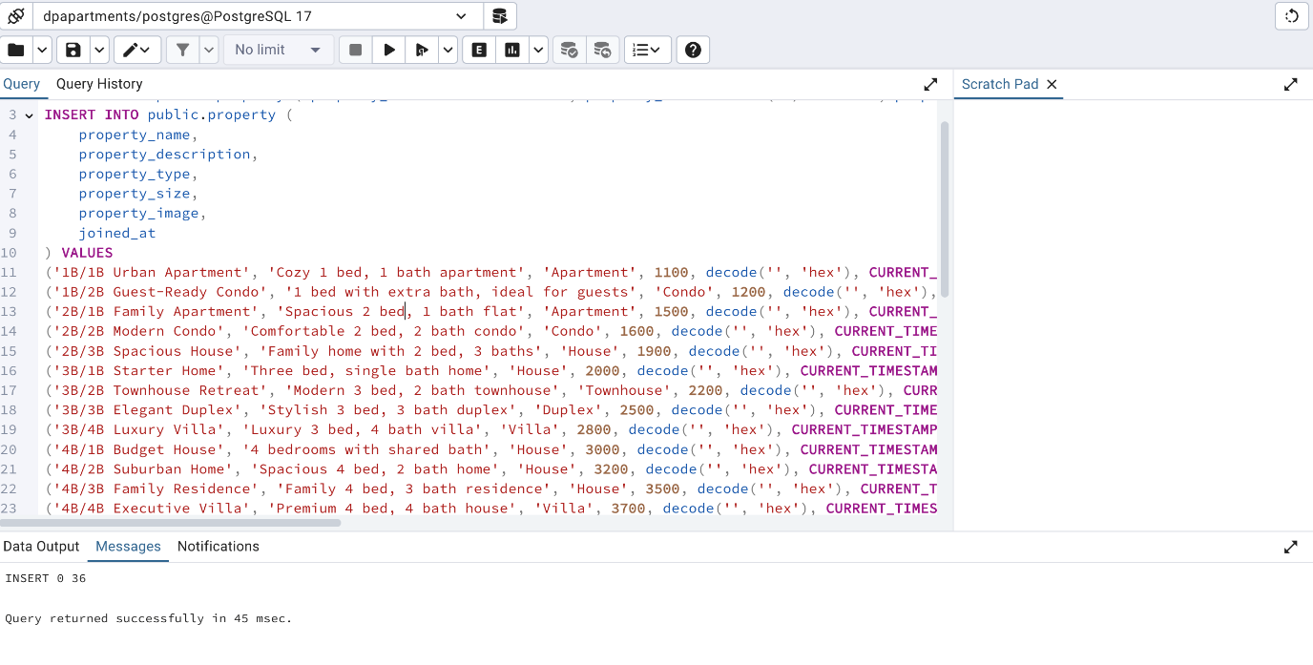

**SQL Result -** Property

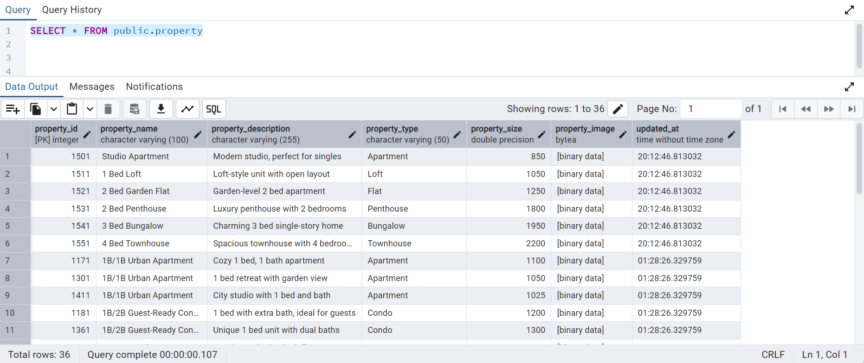

**SQL Sequence Script -** Tenant

CREATE SEQUENCE tenant_tenant_id_seq START WITH 11111 INCREMENT BY 15 MINVALUE 11111 MAXVALUE 99999 CACHE 1;

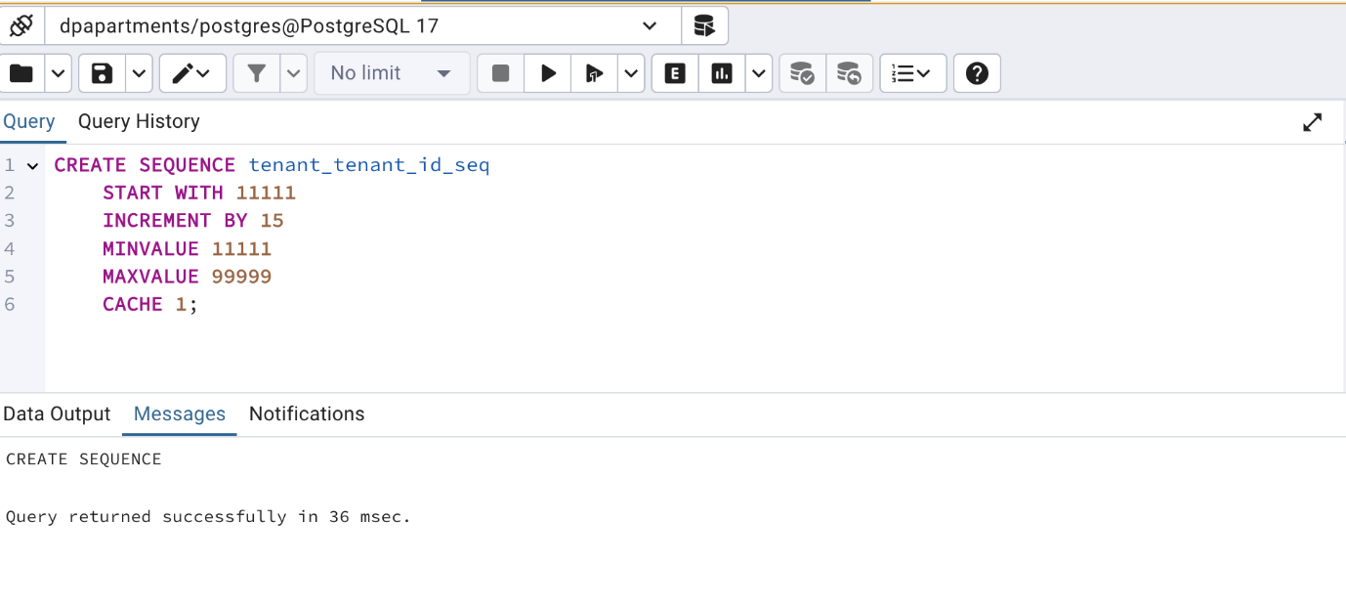**SQL Create Table -** Tenant

CREATE TABLE public.tenant ( tenant_id INTEGER PRIMARY KEY DEFAULT nextval('tenant_tenant_id_seq'), tenant_name VARCHAR(255) NOT NULL, tenant_email VARCHAR(255) UNIQUE NOT NULL, property_number INT UNIQUE NOT NULL, joined_at TIMESTAMP DEFAULT CURRENT_TIMESTAMP, CONSTRAINT fk_tenant_property FOREIGN KEY (property_number) REFERENCES public.property (property_id) ON DELETE CASCADE );

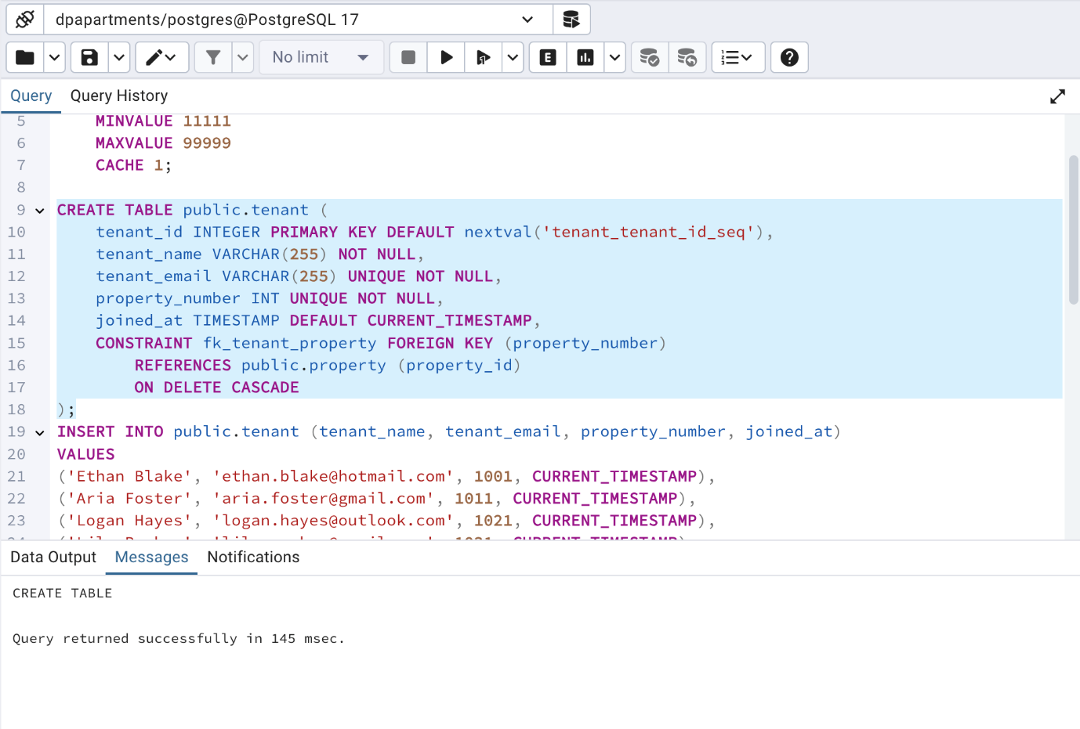

**SQL Insert Table -** Tenant

INSERT INTO public.tenant (tenant_name, tenant_email, property_number, joined_at) VALUES ('Ethan Blake', '[ethan.blake@hotmail.com](mailto:ethan.blake@hotmail.com)', 1001, CURRENT_TIMESTAMP), ('Aria Foster', '[aria.foster@gmail.com](mailto:aria.foster@gmail.com)', 1011, CURRENT_TIMESTAMP), ('Logan Hayes', '[logan.hayes@outlook.com](mailto:logan.hayes@outlook.com)', 1021, CURRENT_TIMESTAMP), ('Lily Parker', '[lily.parker@gmail.com](mailto:lily.parker@gmail.com)', 1031, CURRENT_TIMESTAMP), ('Aiden Rivera', '[aiden.rivera@hotmail.com](mailto:aiden.rivera@hotmail.com)', 1041, CURRENT_TIMESTAMP), ('Chloe Murphy', '[chloe.murphy@outlook.com](mailto:chloe.murphy@outlook.com)', 1051, CURRENT_TIMESTAMP), ('Mason Cooper', '[mason.cooper@gmail.com](mailto:mason.cooper@gmail.com)', 1061, CURRENT_TIMESTAMP), ('Zoe Brooks', '[zoe.brooks@hotmail.com](mailto:zoe.brooks@hotmail.com)', 1071, CURRENT_TIMESTAMP), ('Carter Reed', '[carter.reed@outlook.com](mailto:carter.reed@outlook.com)', 1081, CURRENT_TIMESTAMP), ('Layla Bailey', '[layla.bailey@gmail.com](mailto:layla.bailey@gmail.com)', 1091, CURRENT_TIMESTAMP), ('Jayden Bell', '[jayden.bell@hotmail.com](mailto:jayden.bell@hotmail.com)', 1101, CURRENT_TIMESTAMP), ('Nora Price', '[nora.price@outlook.com](mailto:nora.price@outlook.com)', 1111, CURRENT_TIMESTAMP), ('Levi Barnes', '[levi.barnes@gmail.com](mailto:levi.barnes@gmail.com)', 1121, CURRENT_TIMESTAMP), ('Hannah Ross', '[hannah.ross@hotmail.com](mailto:hannah.ross@hotmail.com)', 1131, CURRENT_TIMESTAMP), ('Dylan Powell', '[dylan.powell@outlook.com](mailto:dylan.powell@outlook.com)', 1141, CURRENT_TIMESTAMP), ('Ella Jenkins', '[ella.jenkins@gmail.com](mailto:ella.jenkins@gmail.com)', 1151, CURRENT_TIMESTAMP), ('Grayson Sanders', '[grayson.sanders@outlook.com](mailto:grayson.sanders@outlook.com)', 1161, CURRENT_TIMESTAMP), ('Aubrey Patterson', '[aubrey.patterson@hotmail.com](mailto:aubrey.patterson@hotmail.com)', 1171, CURRENT_TIMESTAMP), ('Gabriel Long', '[gabriel.long@gmail.com](mailto:gabriel.long@gmail.com)', 1181, CURRENT_TIMESTAMP), ('Addison Hughes', '[addison.hughes@outlook.com](mailto:addison.hughes@outlook.com)', 1191, CURRENT_TIMESTAMP), ('Lincoln Flores', '[lincoln.flores@hotmail.com](mailto:lincoln.flores@hotmail.com)', 1201, CURRENT_TIMESTAMP), ('Violet Bryant', '[violet.bryant@gmail.com](mailto:violet.bryant@gmail.com)', 1211, CURRENT_TIMESTAMP), ('Wyatt Simmons', '[wyatt.simmons@gmail.com](mailto:wyatt.simmons@gmail.com)', 1221, CURRENT_TIMESTAMP), ('Camila Alexander', '[camila.alexander@hotmail.com](mailto:camila.alexander@hotmail.com)', 1231, CURRENT_TIMESTAMP), ('Julian Ward', '[julian.ward@gmail.com](mailto:julian.ward@gmail.com)', 1241, CURRENT_TIMESTAMP), ('Penelope Griffin', '[penelope.griffin@outlook.com](mailto:penelope.griffin@outlook.com)', 1251, CURRENT_TIMESTAMP), ('Luke Hayes', '[luke.hayes@hotmail.com](mailto:luke.hayes@hotmail.com)', 1261, CURRENT_TIMESTAMP), ('Savannah Watson', '[savannah.watson@gmail.com](mailto:savannah.watson@gmail.com)', 1271, CURRENT_TIMESTAMP), ('Isaac West', '[isaac.west@outlook.com](mailto:isaac.west@outlook.com)', 1281, CURRENT_TIMESTAMP), ('Aurora Fisher', '[aurora.fisher@gmail.com](mailto:aurora.fisher@gmail.com)', 1291, CURRENT_TIMESTAMP);

**SQL Screenshot -** Tenant

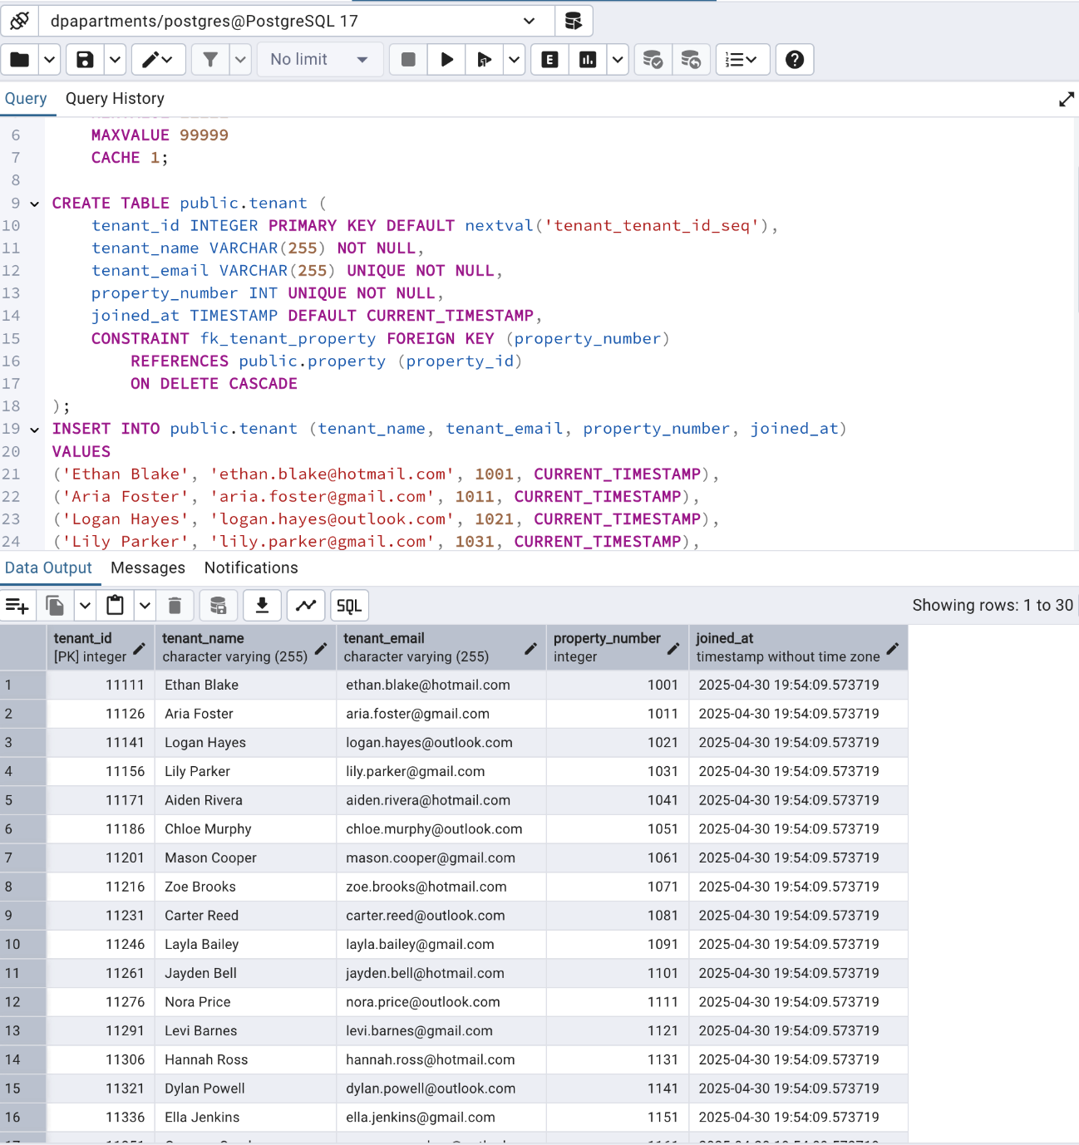

**SQL Sequence Script –** Manager

CREATE SEQUENCE manager_manager_id_seq START WITH 10001 INCREMENT BY 100 MINVALUE 10001 MAXVALUE 99999 CACHE 1;

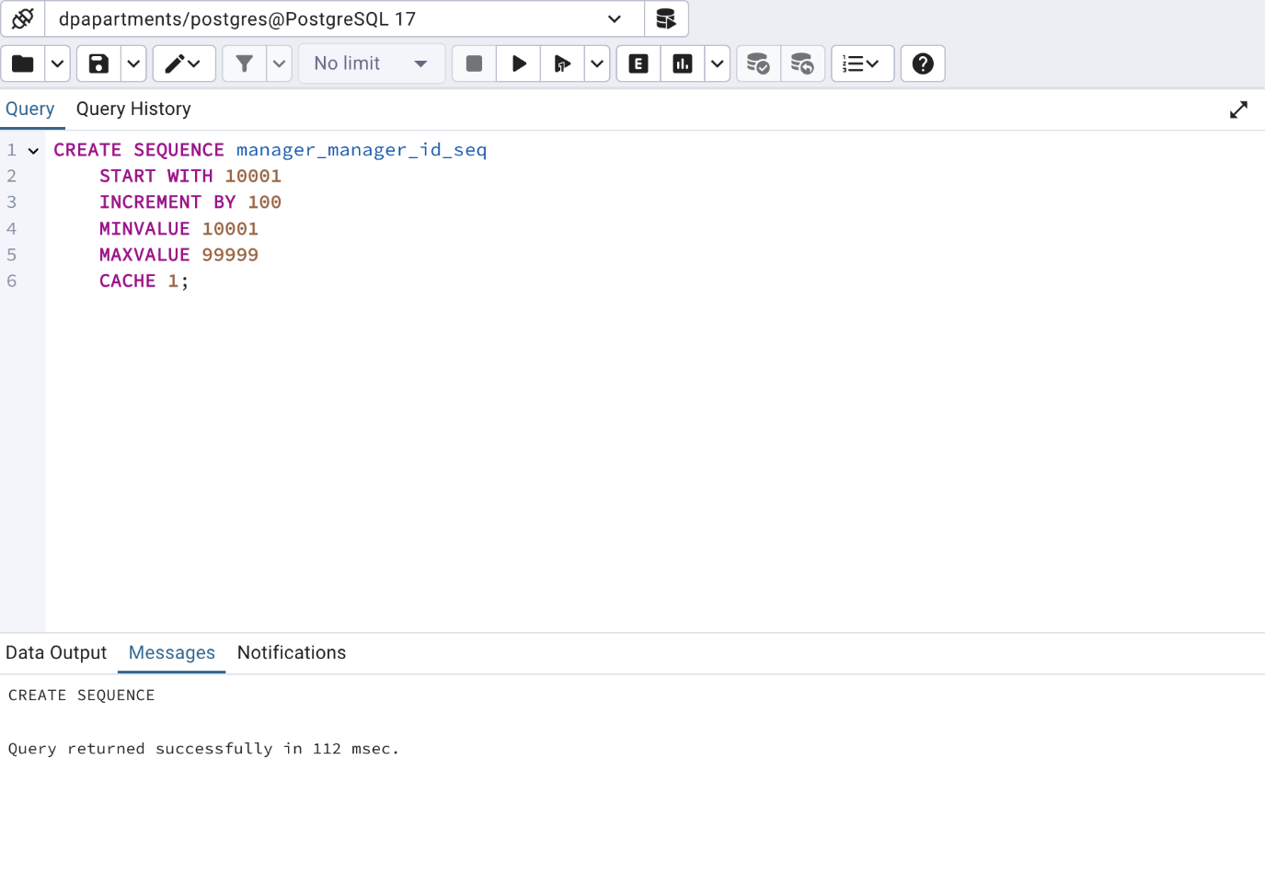**SQL Create Table –** Manager

CREATE TABLE public.manager ( manager_id INTEGER PRIMARY KEY DEFAULT nextval('manager_manager_id_seq'), manager_name VARCHAR(255) NOT NULL, manager_email VARCHAR(255) NOT NULL, property_number INT, joined_at TIMESTAMP DEFAULT CURRENT_TIMESTAMP, CONSTRAINT fk_manager_house FOREIGN KEY (property_number) REFERENCES public.property (property_id) ON DELETE CASCADE );

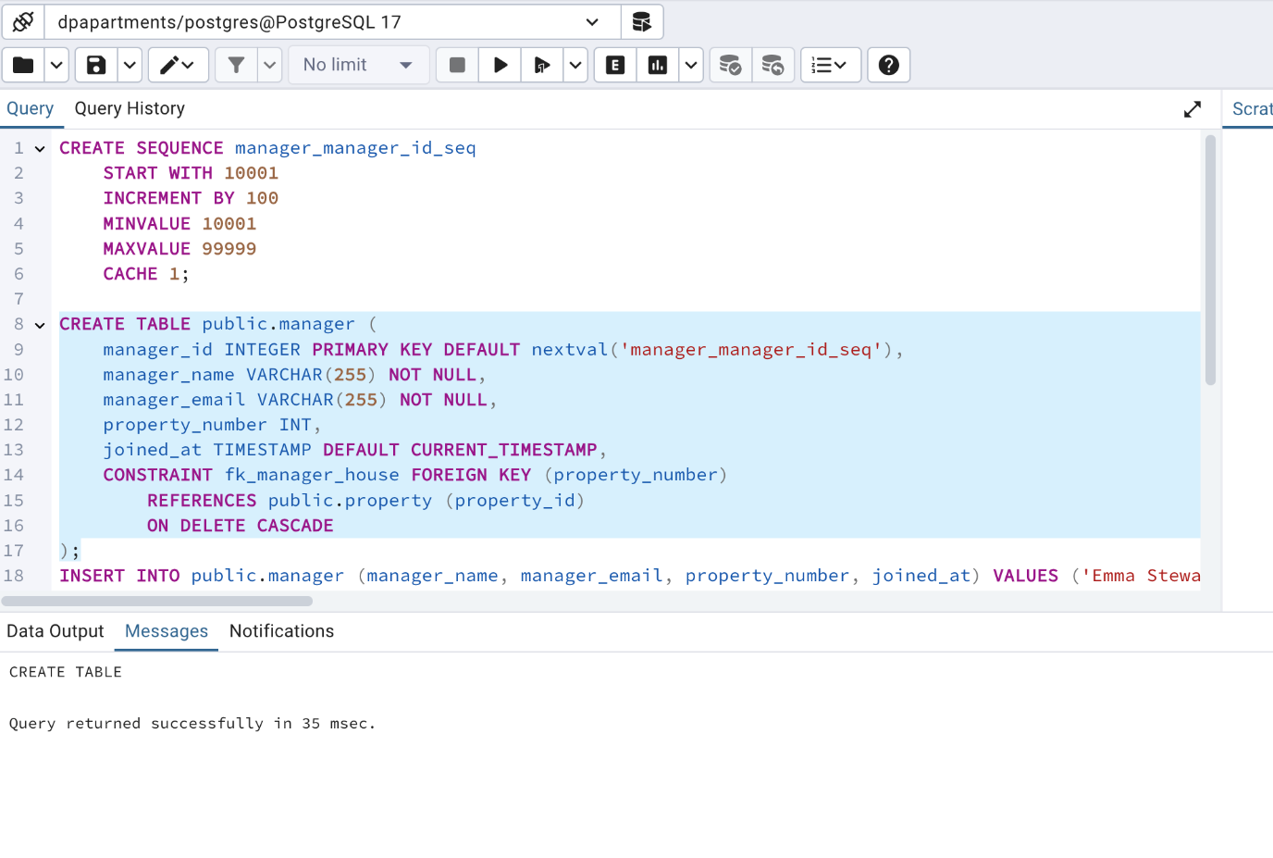

**SQL Insert Table –** Manager

INSERT INTO public.manager (manager_name, manager_email, property_number, joined_at) VALUES ('Emma Stewart', '[emma.stewart@dpapartments.com](mailto:emma.stewart@dpapartments.com)', 1171, CURRENT_TIMESTAMP), ('Emma Stewart', '[emma.stewart@dpapartments.com](mailto:emma.stewart@dpapartments.com)', 1181, CURRENT_TIMESTAMP), ('Emma Stewart', '[emma.stewart@dpapartments.com](mailto:emma.stewart@dpapartments.com)', 1191, CURRENT_TIMESTAMP), ('Emma Stewart', '[emma.stewart@dpapartments.com](mailto:emma.stewart@dpapartments.com)', 1201, CURRENT_TIMESTAMP);

INSERT INTO public.manager (manager_name, manager_email, property_number, joined_at) VALUES ('Daniel Cruz', '[daniel.cruz@dpapartments.com](mailto:daniel.cruz@dpapartments.com)', 1211, CURRENT_TIMESTAMP), ('Daniel Cruz', '[daniel.cruz@dpapartments.com](mailto:daniel.cruz@dpapartments.com)', 1221, CURRENT_TIMESTAMP), ('Daniel Cruz', '[daniel.cruz@dpapartments.com](mailto:daniel.cruz@dpapartments.com)', 1231, CURRENT_TIMESTAMP), ('Daniel Cruz', '[daniel.cruz@dpapartments.com](mailto:daniel.cruz@dpapartments.com)', 1241, CURRENT_TIMESTAMP);

INSERT INTO public.manager (manager_name, manager_email, property_number, joined_at) VALUES ('Olivia Morgan', '[olivia.morgan@dpapartments.com](mailto:olivia.morgan@dpapartments.com)', 1251, CURRENT_TIMESTAMP), ('Olivia Morgan', '[olivia.morgan@dpapartments.com](mailto:olivia.morgan@dpapartments.com)', 1261, CURRENT_TIMESTAMP), ('Olivia Morgan', '[olivia.morgan@dpapartments.com](mailto:olivia.morgan@dpapartments.com)', 1271, CURRENT_TIMESTAMP), ('Olivia Morgan', '[olivia.morgan@dpapartments.com](mailto:olivia.morgan@dpapartments.com)', 1281, CURRENT_TIMESTAMP);

INSERT INTO public.manager (manager_name, manager_email, property_number, joined_at) VALUES ('Ethan James', '[ethan.james@dpapartments.com](mailto:ethan.james@dpapartments.com)', 1291, CURRENT_TIMESTAMP), ('Ethan James', '[ethan.james@dpapartments.com](mailto:ethan.james@dpapartments.com)', 1301, CURRENT_TIMESTAMP), ('Ethan James', '[ethan.james@dpapartments.com](mailto:ethan.james@dpapartments.com)', 1311, CURRENT_TIMESTAMP), ('Ethan James', '[ethan.james@dpapartments.com](mailto:ethan.james@dpapartments.com)', 1321, CURRENT_TIMESTAMP);

INSERT INTO public.manager (manager_name, manager_email, property_number, joined_at) VALUES ('Sophia Allen', '[sophia.allen@dpapartments.com](mailto:sophia.allen@dpapartments.com)', 1001, CURRENT_TIMESTAMP), ('Sophia Allen', '[sophia.allen@dpapartments.com](mailto:sophia.allen@dpapartments.com)', 1011, CURRENT_TIMESTAMP), ('Sophia Allen', '[sophia.allen@dpapartments.com](mailto:sophia.allen@dpapartments.com)', 1021, CURRENT_TIMESTAMP), ('Sophia Allen', '[sophia.allen@dpapartments.com](mailto:sophia.allen@dpapartments.com)', 1031, CURRENT_TIMESTAMP);

INSERT INTO public.manager (manager_name, manager_email, property_number, joined_at) VALUES ('Liam Rivera', '[liam.rivera@dpapartments.com](mailto:liam.rivera@dpapartments.com)', 1041, CURRENT_TIMESTAMP), ('Liam Rivera', '[liam.rivera@dpapartments.com](mailto:liam.rivera@dpapartments.com)', 1051, CURRENT_TIMESTAMP), ('Liam Rivera', '[liam.rivera@dpapartments.com](mailto:liam.rivera@dpapartments.com)', 1061, CURRENT_TIMESTAMP), ('Liam Rivera', '[liam.rivera@dpapartments.com](mailto:liam.rivera@dpapartments.com)', 1071, CURRENT_TIMESTAMP);

INSERT INTO public.manager (manager_name, manager_email, property_number, joined_at) VALUES ('Ava Bennett', '[ava.bennett@dpapartments.com](mailto:ava.bennett@dpapartments.com)', 1081, CURRENT_TIMESTAMP), ('Ava Bennett', '[ava.bennett@dpapartments.com](mailto:ava.bennett@dpapartments.com)', 1091, CURRENT_TIMESTAMP), ('Ava Bennett', '[ava.bennett@dpapartments.com](mailto:ava.bennett@dpapartments.com)', 1101, CURRENT_TIMESTAMP), ('Ava Bennett', '[ava.bennett@dpapartments.com](mailto:ava.bennett@dpapartments.com)', 1111, CURRENT_TIMESTAMP);

INSERT INTO public.manager (manager_name, manager_email, property_number, joined_at) VALUES ('Noah Coleman', '[noah.coleman@dpapartments.com](mailto:noah.coleman@dpapartments.com)', 1121, CURRENT_TIMESTAMP), ('Noah Coleman', '[noah.coleman@dpapartments.com](mailto:noah.coleman@dpapartments.com)', 1131, CURRENT_TIMESTAMP);

**SQL Result -** Manager

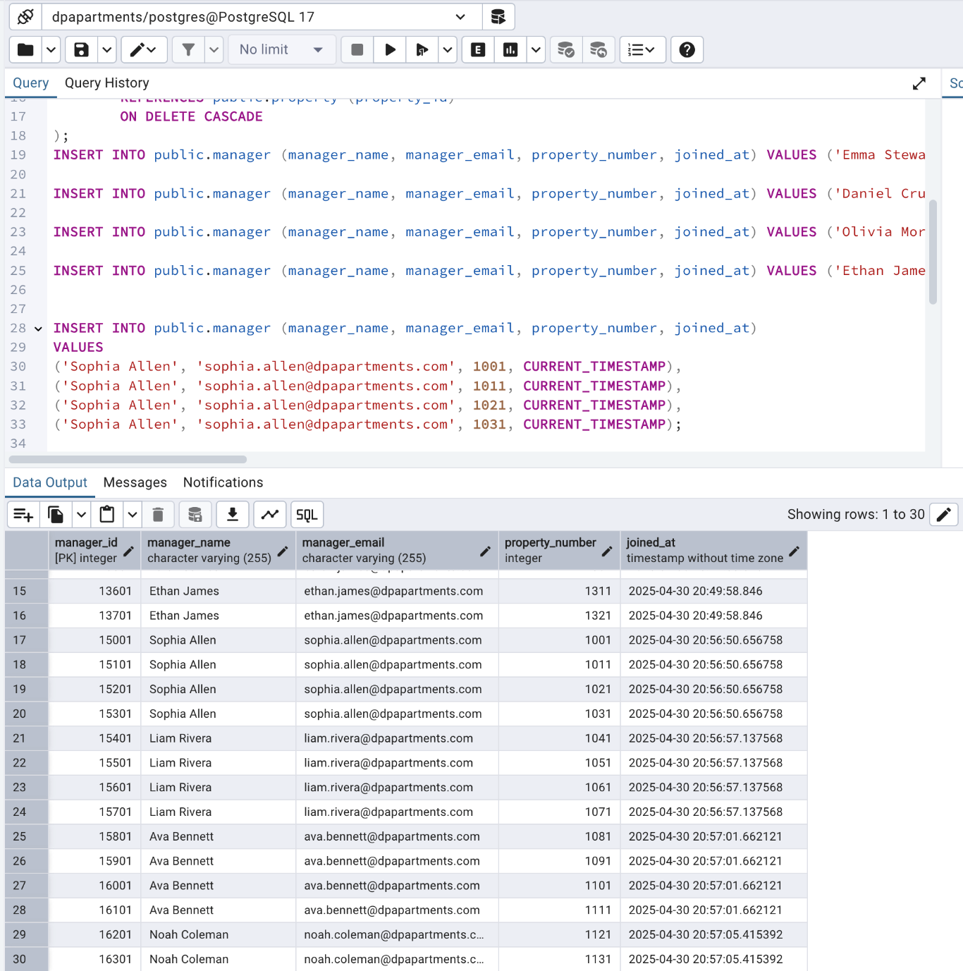

**SQL Sequence Script –** Owner

CREATE SEQUENCE owner_owner_id_seq  
 START WITH 10000  
 INCREMENT BY 25  
 MINVALUE 10000  
 MAXVALUE 99999  
 CACHE 1;

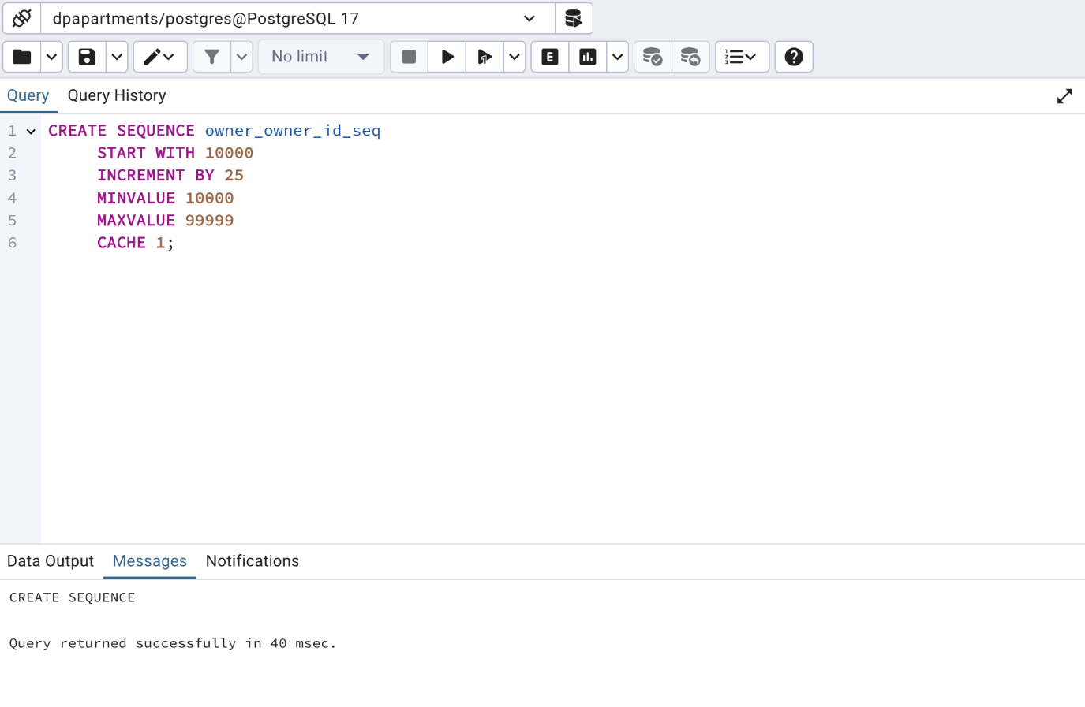

**SQL Create Table –** Owner

CREATE TABLE public.owner ( owner_id INTEGER PRIMARY KEY DEFAULT nextval('owner_owner_id_seq'), owner_name VARCHAR(255) NOT NULL, owner_email VARCHAR(255) UNIQUE NOT NULL, property_number INT NOT NULL, joined_at TIMESTAMP DEFAULT CURRENT_TIMESTAMP, CONSTRAINT fk_owner_property FOREIGN KEY (property_number) REFERENCES public.property (property_id) ON DELETE CASCADE );

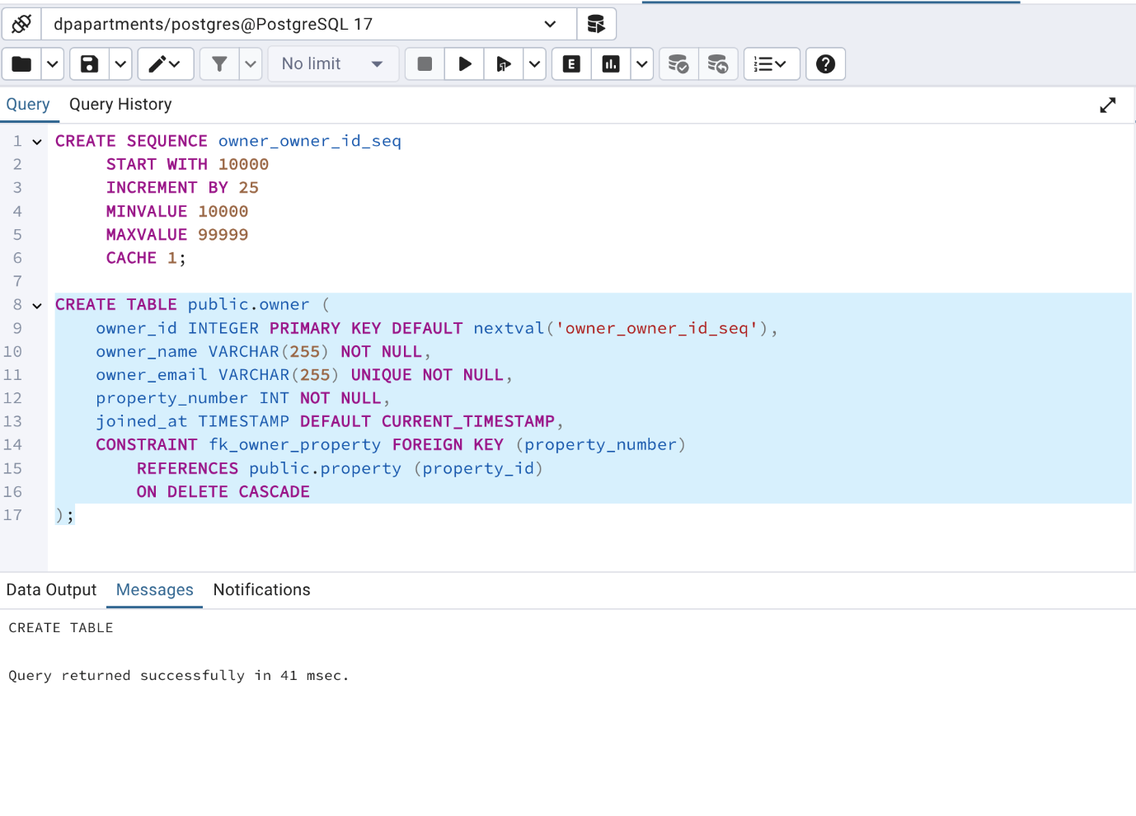

**SQL Insert Table –** Owner

INSERT INTO public.owner (owner_name, owner_email, property_number, joined_at) VALUES ('Matthew Green', '[matthew.green@modernhousehub.com](mailto:matthew.green@modernhousehub.com)', 1001, CURRENT_TIMESTAMP), ('Abigail Adams', '[abigail.adams@realtyconnect.com](mailto:abigail.adams@realtyconnect.com)', 1011, CURRENT_TIMESTAMP), ('Sebastian Baker', '[sebastian.baker@openkeygroup.com](mailto:sebastian.baker@openkeygroup.com)', 1021, CURRENT_TIMESTAMP), ('Ella Nelson', '[ella.nelson@secureholdings.com](mailto:ella.nelson@secureholdings.com)', 1031, CURRENT_TIMESTAMP), ('Jackson Carter', '[jackson.carter@zenhomes.com](mailto:jackson.carter@zenhomes.com)', 1041, CURRENT_TIMESTAMP), ('Scarlett Mitchell', '[scarlett.mitchell@nextkeyliving.com](mailto:scarlett.mitchell@nextkeyliving.com)', 1051, CURRENT_TIMESTAMP), ('David Perez', '[david.perez@easylivingmail.com](mailto:david.perez@easylivingmail.com)', 1061, CURRENT_TIMESTAMP), ('Emily Roberts', '[emily.roberts@primeowners.com](mailto:emily.roberts@primeowners.com)', 1071, CURRENT_TIMESTAMP), ('Joseph Turner', '[joseph.turner@houselaunch.com](mailto:joseph.turner@houselaunch.com)', 1081, CURRENT_TIMESTAMP), ('Grace Phillips', '[grace.phillips@valuehomes.com](mailto:grace.phillips@valuehomes.com)', 1091, CURRENT_TIMESTAMP), ('Samuel Campbell', '[samuel.campbell@trustrealty.com](mailto:samuel.campbell@trustrealty.com)', 1101, CURRENT_TIMESTAMP), ('Emma Thompson', '[emma.thompson@realestatehub.com](mailto:emma.thompson@realestatehub.com)', 1171, CURRENT_TIMESTAMP), ('Liam Johnson', '[liam.johnson@homesdirect.com](mailto:liam.johnson@homesdirect.com)', 1181, CURRENT_TIMESTAMP), ('Olivia Davis', '[olivia.davis@propertymail.com](mailto:olivia.davis@propertymail.com)', 1191, CURRENT_TIMESTAMP), ('Noah Wilson', '[noah.wilson@urbanhomes.com](mailto:noah.wilson@urbanhomes.com)', 1201, CURRENT_TIMESTAMP), ('Ava Martinez', '[ava.martinez@ownitnow.com](mailto:ava.martinez@ownitnow.com)', 1211, CURRENT_TIMESTAMP), ('Elijah Anderson', '[elijah.anderson@keyholdings.com](mailto:elijah.anderson@keyholdings.com)', 1221, CURRENT_TIMESTAMP), ('Sophia Lee', '[sophia.lee@estatecloud.com](mailto:sophia.lee@estatecloud.com)', 1231, CURRENT_TIMESTAMP), ('James Taylor', '[james.taylor@dreamresidences.com](mailto:james.taylor@dreamresidences.com)', 1241, CURRENT_TIMESTAMP), ('Isabella Moore', '[isabella.moore@housenet.com](mailto:isabella.moore@housenet.com)', 1251, CURRENT_TIMESTAMP), ('Benjamin Harris', '[benjamin.harris@domoholdings.com](mailto:benjamin.harris@domoholdings.com)', 1261, CURRENT_TIMESTAMP), ('Mia Clark', '[mia.clark@premierprops.com](mailto:mia.clark@premierprops.com)', 1271, CURRENT_TIMESTAMP), ('Lucas Lewis', '[lucas.lewis@residex.com](mailto:lucas.lewis@residex.com)', 1281, CURRENT_TIMESTAMP), ('Charlotte Walker', '[charlotte.walker@myvilla.com](mailto:charlotte.walker@myvilla.com)', 1291, CURRENT_TIMESTAMP), ('Henry Young', '[henry.young@homelandmail.com](mailto:henry.young@homelandmail.com)', 1301, CURRENT_TIMESTAMP), ('Amelia Hall', '[amelia.hall@urbanestates.com](mailto:amelia.hall@urbanestates.com)', 1311, CURRENT_TIMESTAMP), ('Alexander Allen', '[alexander.allen@yourspace.com](mailto:alexander.allen@yourspace.com)', 1321, CURRENT_TIMESTAMP), ('Harper King', '[harper.king@truehomeowners.com](mailto:harper.king@truehomeowners.com)', 1331, CURRENT_TIMESTAMP), ('Daniel Wright', '[daniel.wright@estatexpress.com](mailto:daniel.wright@estatexpress.com)', 1341, CURRENT_TIMESTAMP), ('Evelyn Scott', '[evelyn.scott@greenkeyhomes.com](mailto:evelyn.scott@greenkeyhomes.com)', 1351, CURRENT_TIMESTAMP);

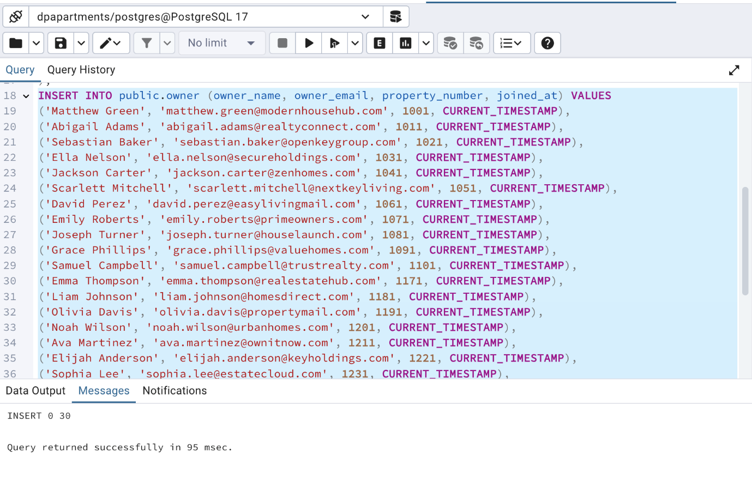

**SQL Result -** Owner

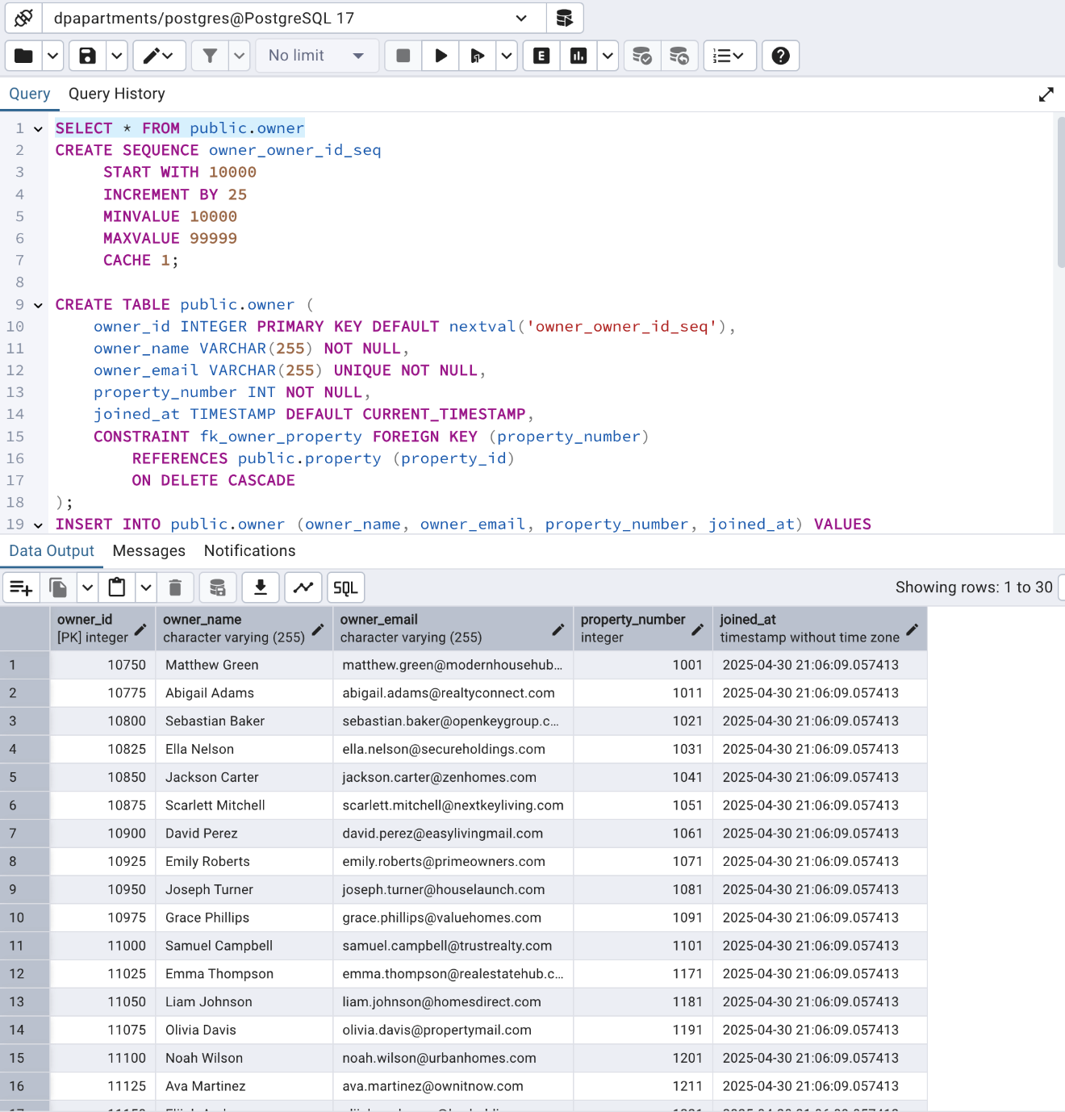

**SQL Sequence Script-** Lease File

CREATE SEQUENCE lease_file_file_id_seq START WITH 101 INCREMENT BY 1 MINVALUE 101 MAXVALUE 999 CACHE 1;

CREATE SEQUENCE lease_file_lease_number_seq START WITH 100001 INCREMENT BY 10 MINVALUE 100001 MAXVALUE 999999 CACHE 1;

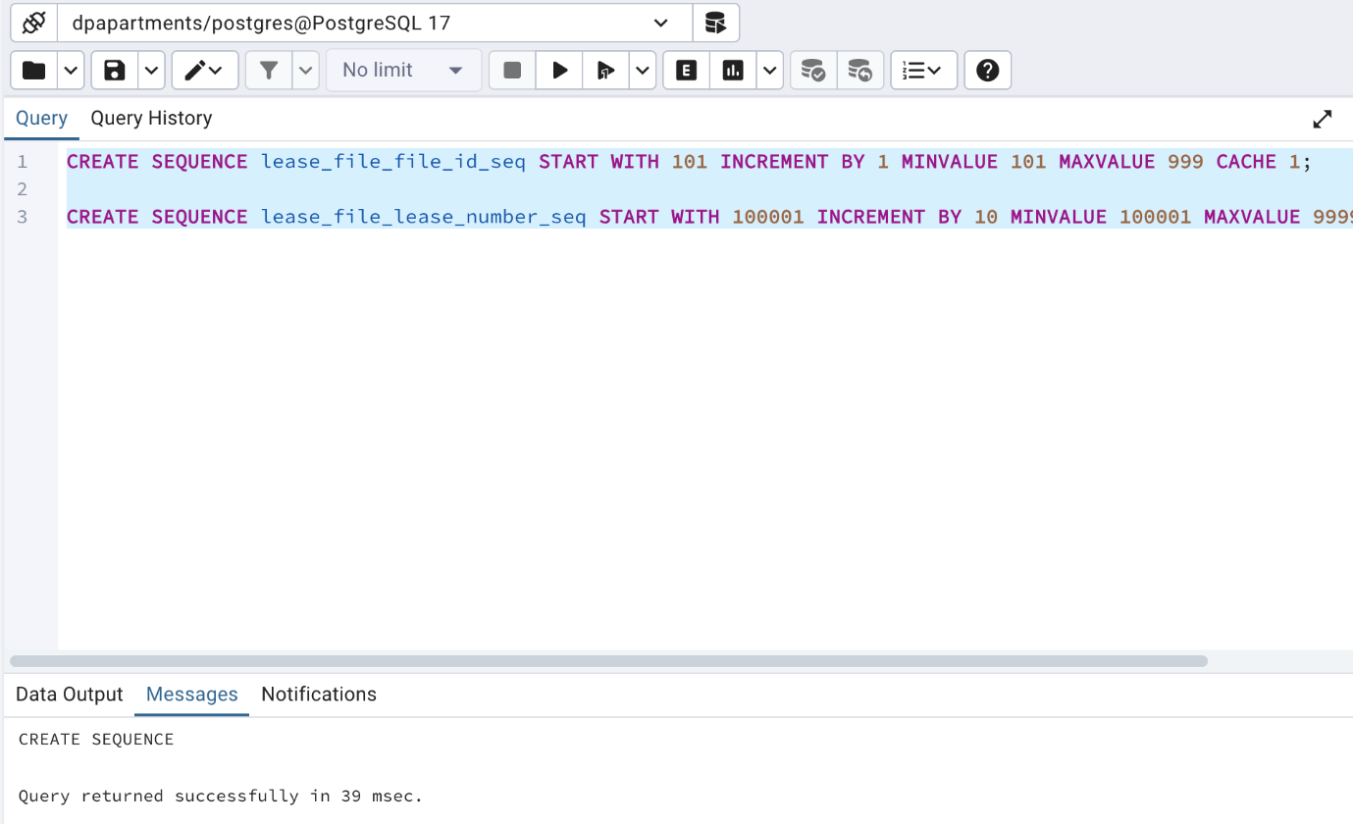

**SQL Create Table –** Lease File

CREATE TABLE public.lease_file ( file_id INTEGER PRIMARY KEY DEFAULT nextval('lease_file_file_id_seq'), property_id INT UNIQUE NOT NULL, lease_number INTEGER NOT NULL DEFAULT nextval('lease_file_lease_number_seq'), lease_start_date DATE NOT NULL, lease_end_date DATE NOT NULL, lease_document BYTEA NOT NULL, rent_amount INT, uploaded_at TIMESTAMP DEFAULT CURRENT_TIMESTAMP, CONSTRAINT fk_lease_file_property FOREIGN KEY (property_id) REFERENCES public.property (property_id) ON DELETE CASCADE );

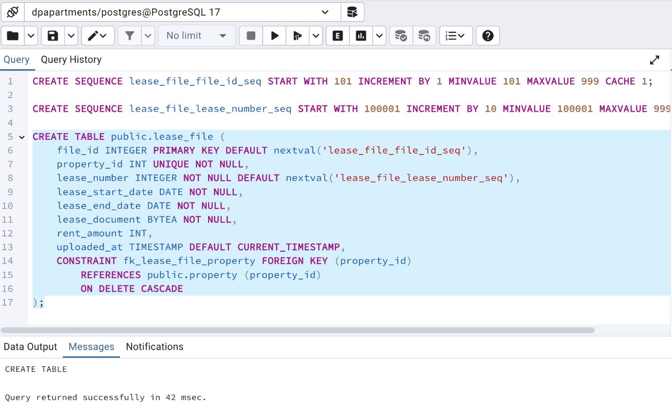

**SQL Insert Table -** Lease File

INSERT INTO public.lease_file ( property_id, lease_number, lease_start_date, lease_end_date, lease_document, rent_amount, uploaded_at ) VALUES (1001, 12049, '2024-08-15', '2025-05-05', '\xDEADBEEF', 1600, CURRENT_TIMESTAMP),

'\xDEADBEEF', 1650, CURRENT_TIMESTAMP),

'\xDEADBEEF', 1700, CURRENT_TIMESTAMP), -- altered (1031, 78215, '2024-11-15', '2025-05-25', '\xDEADBEEF', 1750, CURRENT_TIMESTAMP), -- altered (1041, 40291, '2022-12-15', '2023-12-15', '\xDEADBEEF', 1800, CURRENT_TIMESTAMP), (1051, 14321, '2021-01-01', '2022-01-01', '\xDEADBEEF', 1900, CURRENT_TIMESTAMP), (1061, 20473, '2021-02-01', '2022-02-01', '\xDEADBEEF', 2000, CURRENT_TIMESTAMP), (1071, 98421, '2021-03-01', '2022-03-01', '\xDEADBEEF', 2100, CURRENT_TIMESTAMP), (1081, 50391, '2021-04-01', '2022-04-01', '\xDEADBEEF', 2200, CURRENT_TIMESTAMP), (1091, 74852, '2021-05-01', '2022-05-01', '\xDEADBEEF', 2300, CURRENT_TIMESTAMP), (1101, 61284, '2021-06-01', '2022-06-01', '\xDEADBEEF', 2400, CURRENT_TIMESTAMP), (1171, 54321, '2023-01-01', '2024-01-01', '\xDEADBEEF', 1400, CURRENT_TIMESTAMP), (1181, 19875, '2023-02-01', '2024-02-01', '\xDEADBEEF', 1550, CURRENT_TIMESTAMP), (1191, 34219, '2023-03-01', '2024-03-01', '\xDEADBEEF', 1650, CURRENT_TIMESTAMP), (1201, 78562, '2023-04-01', '2024-04-01', '\xDEADBEEF', 1800, CURRENT_TIMESTAMP), (1211, 61783, '2023-05-01', '2024-05-01', '\xDEADBEEF', 1450, CURRENT_TIMESTAMP), (1221, 29314, '2023-06-01', '2024-06-01', '\xDEADBEEF', 1350, CURRENT_TIMESTAMP), (1231, 87392, '2023-07-01', '2024-07-01', '\xDEADBEEF', 2100, CURRENT_TIMESTAMP), (1241, 19824, '2023-08-01', '2024-08-01', '\xDEADBEEF', 1900, CURRENT_TIMESTAMP), (1251, 32014, '2023-09-01', '2024-09-01', '\xDEADBEEF', 1750, CURRENT_TIMESTAMP), (1261, 45920, '2023-10-01', '2024-10-01', '\xDEADBEEF', 1600, CURRENT_TIMESTAMP), (1271, 10485, '2023-11-01', '2024-11-01', '\xDEADBEEF', 1700, CURRENT_TIMESTAMP), (1281, 39421, '2023-12-01', '2024-12-01', '\xDEADBEEF', 1850, CURRENT_TIMESTAMP), (1291, 20489, '2022-01-15', '2023-01-15', '\xDEADBEEF', 1250, CURRENT_TIMESTAMP), (1301, 88391, '2022-02-15', '2023-02-15', '\xDEADBEEF', 1300, CURRENT_TIMESTAMP), (1311, 67429, '2022-03-15', '2023-03-15', '\xDEADBEEF', 1350, CURRENT_TIMESTAMP), (1321, 90213, '2022-04-15', '2023-04-15', '\xDEADBEEF', 1400, CURRENT_TIMESTAMP), (1331, 15426, '2022-05-15', '2023-05-15', '\xDEADBEEF', 1450, CURRENT_TIMESTAMP), (1341, 23014, '2022-06-15', '2023-06-15', '\xDEADBEEF', 1500, CURRENT_TIMESTAMP), (1351, 90284, '2022-07-15', '2023-07-15', '\xDEADBEEF', 1550, CURRENT_TIMESTAMP);

**SQL Result -** Lease File

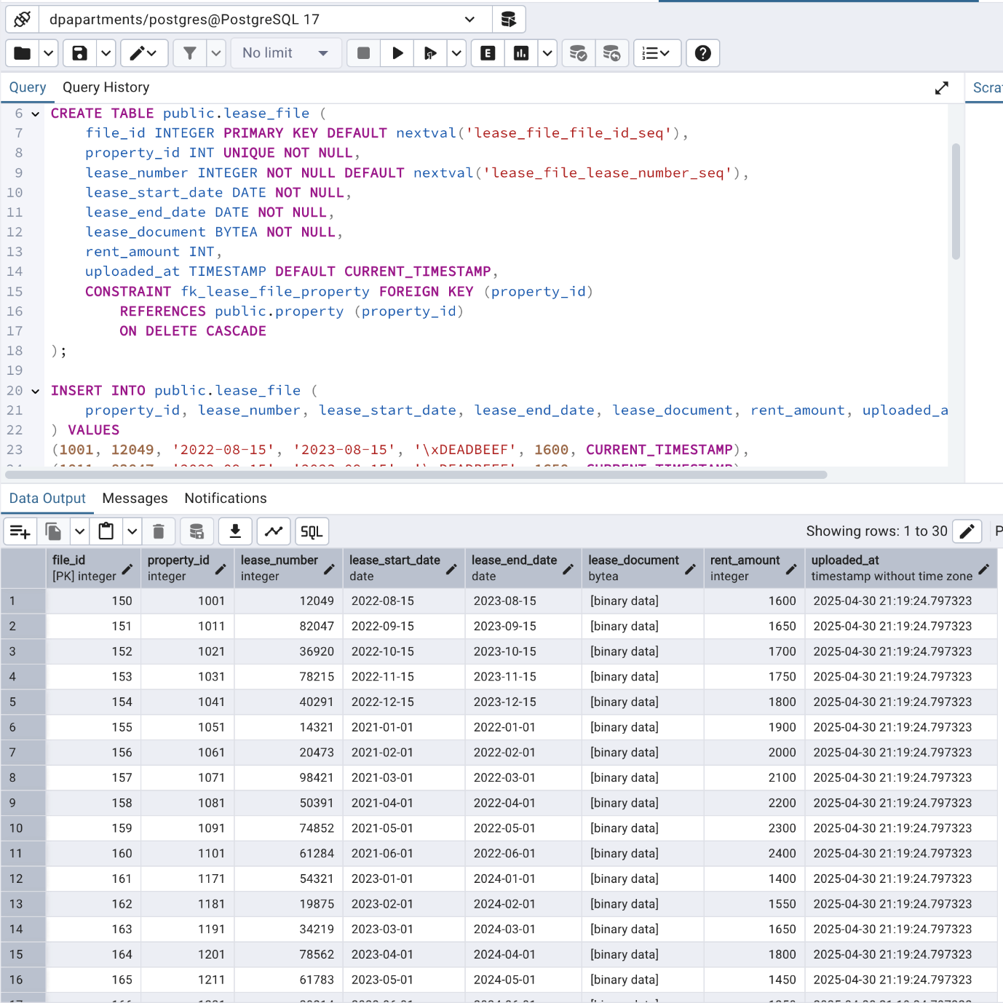

**SQL Trigger Functions –** Payment

CREATE OR REPLACE FUNCTION generate_payment_id() RETURNS TRIGGER AS $$ DECLARE random_part TEXT; suffix_part TEXT; BEGIN random_part := lpad((trunc(random() * 90000 + 10000)::int)::text, 5, '0'); suffix_part := (trunc(random() * 90 + 10)::int)::text; NEW.payment_id := random_part || '-' || suffix_part; RETURN NEW; END; $$ LANGUAGE plpgsql;

CREATE OR REPLACE FUNCTION generate_transaction_reference() RETURNS TRIGGER AS $$ DECLARE yyyymm TEXT; random_suffix TEXT; BEGIN yyyymm := TO_CHAR(CURRENT_DATE, 'YYYYMM'); random_suffix := lpad((trunc(random() * 900 + 100)::int)::text, 3, '0'); NEW.transaction_reference := 'TX' || yyyymm || NEW.property_number || random_suffix; RETURN NEW; END; $$ LANGUAGE plpgsql;

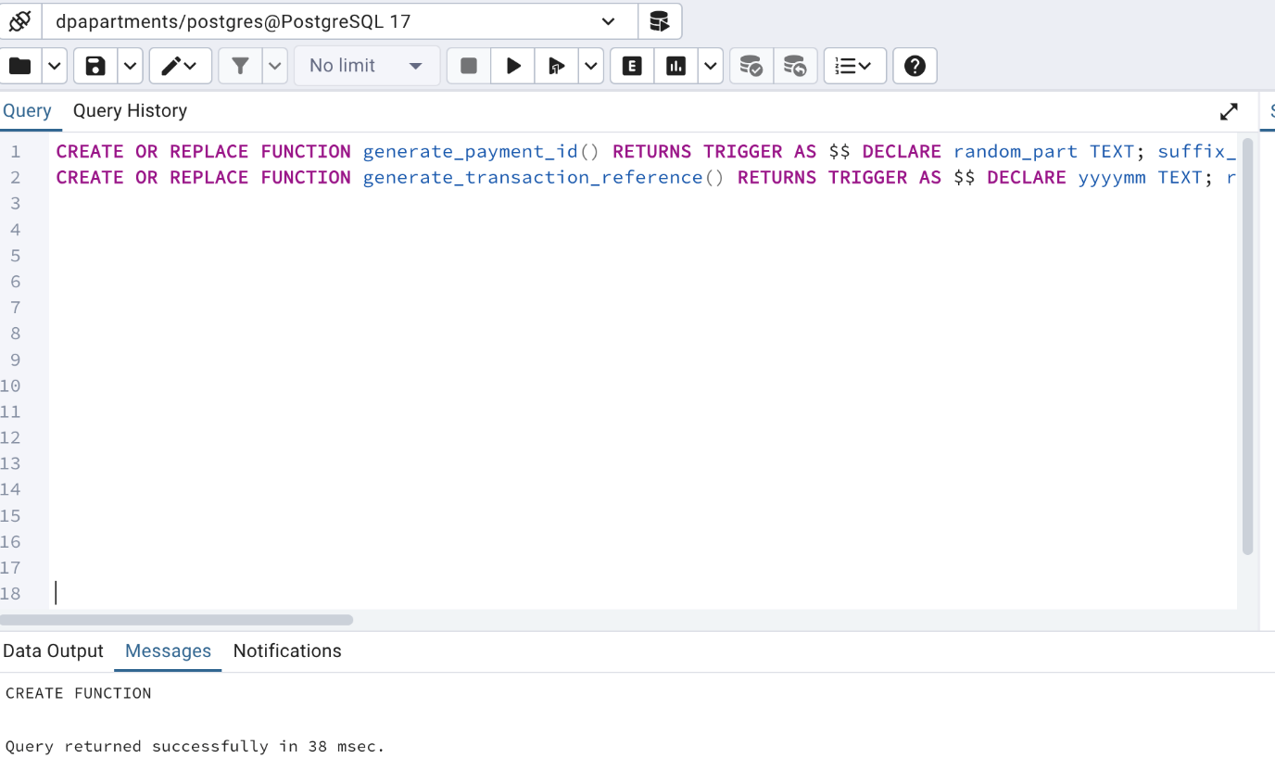

**SQL Create Table –** Payment

CREATE TABLE public.payment ( payment_id TEXT PRIMARY KEY, property_number INT NOT NULL, payment_date TIMESTAMP DEFAULT CURRENT_TIMESTAMP, payment_method VARCHAR(100) NOT NULL, transaction_reference VARCHAR(255) UNIQUE, payment_status VARCHAR(50) DEFAULT 'Pending', lastupdated_at TIMESTAMP DEFAULT CURRENT_TIMESTAMP, CONSTRAINT fk_property FOREIGN KEY (property_number) REFERENCES public.property (property_id) ON DELETE CASCADE );

CREATE TRIGGER set_payment_id BEFORE INSERT ON public.payment FOR EACH ROW WHEN (NEW.payment_id IS NULL) EXECUTE FUNCTION generate_payment_id();

CREATE TRIGGER set_transaction_reference BEFORE INSERT ON public.payment FOR EACH ROW WHEN (NEW.transaction_reference IS NULL) EXECUTE FUNCTION generate_transaction_reference();

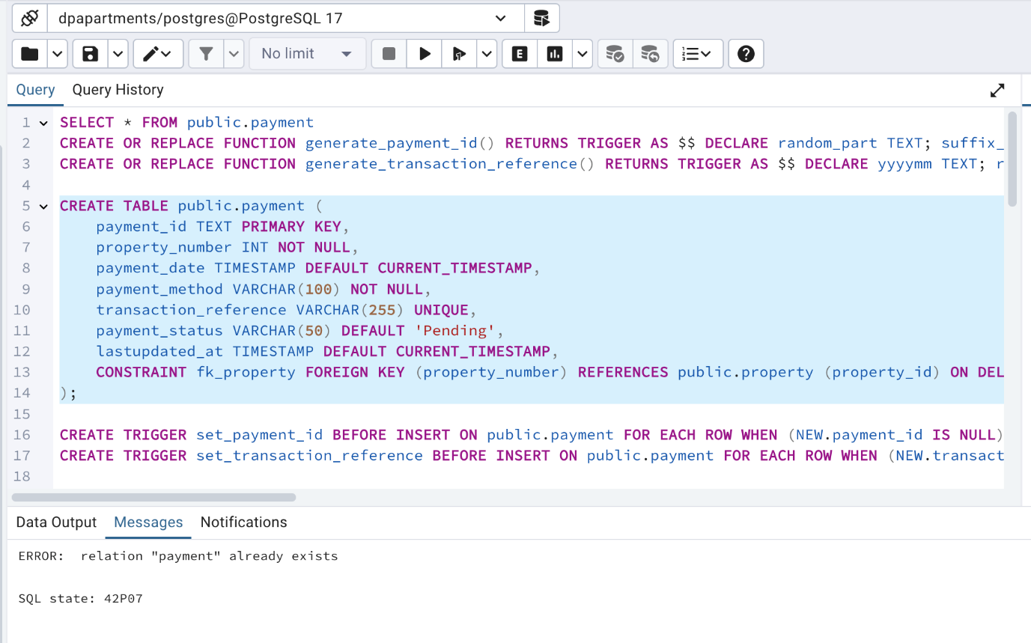

**SQL Insert Table –** Payment

INSERT INTO public.payment ( property_number, payment_date, payment_method, payment_status, lastupdated_at ) VALUES (1001, CURRENT_TIMESTAMP, 'Credit Card', 'Completed', CURRENT_TIMESTAMP), (1011, CURRENT_TIMESTAMP, 'Bank Transfer', 'Pending', CURRENT_TIMESTAMP), (1021, CURRENT_TIMESTAMP, 'Online Portal', 'Completed', CURRENT_TIMESTAMP), (1031, CURRENT_TIMESTAMP, 'Credit Card', 'Failed', CURRENT_TIMESTAMP), (1041, CURRENT_TIMESTAMP, 'Cash', 'Pending', CURRENT_TIMESTAMP), (1051, CURRENT_TIMESTAMP, 'Bank Transfer', 'Completed', CURRENT_TIMESTAMP), (1061, CURRENT_TIMESTAMP, 'Online Portal', 'Completed', CURRENT_TIMESTAMP), (1071, CURRENT_TIMESTAMP, 'Credit Card', 'Pending', CURRENT_TIMESTAMP), (1081, CURRENT_TIMESTAMP, 'Bank Transfer', 'Completed', CURRENT_TIMESTAMP), (1091, CURRENT_TIMESTAMP, 'Cash', 'Completed', CURRENT_TIMESTAMP), (1101, CURRENT_TIMESTAMP, 'Online Portal', 'Failed', CURRENT_TIMESTAMP), (1111, CURRENT_TIMESTAMP, 'Credit Card', 'Completed', CURRENT_TIMESTAMP), (1121, CURRENT_TIMESTAMP, 'Bank Transfer', 'Completed', CURRENT_TIMESTAMP), (1131, CURRENT_TIMESTAMP, 'Cash', 'Pending', CURRENT_TIMESTAMP), (1141, CURRENT_TIMESTAMP, 'Online Portal', 'Completed', CURRENT_TIMESTAMP), (1151, CURRENT_TIMESTAMP, 'Credit Card', 'Completed', CURRENT_TIMESTAMP), (1161, CURRENT_TIMESTAMP, 'Bank Transfer', 'Pending', CURRENT_TIMESTAMP), (1171, CURRENT_TIMESTAMP, 'Cash', 'Completed', CURRENT_TIMESTAMP), (1181, CURRENT_TIMESTAMP, 'Online Portal', 'Failed', CURRENT_TIMESTAMP), (1191, CURRENT_TIMESTAMP, 'Credit Card', 'Completed', CURRENT_TIMESTAMP), (1201, CURRENT_TIMESTAMP, 'Cash', 'Completed', CURRENT_TIMESTAMP), (1211, CURRENT_TIMESTAMP, 'Bank Transfer', 'Failed', CURRENT_TIMESTAMP), (1221, CURRENT_TIMESTAMP, 'Online Portal', 'Completed', CURRENT_TIMESTAMP), (1231, CURRENT_TIMESTAMP, 'Credit Card', 'Pending', CURRENT_TIMESTAMP), (1241, CURRENT_TIMESTAMP, 'Cash', 'Completed', CURRENT_TIMESTAMP), (1251, CURRENT_TIMESTAMP, 'Bank Transfer', 'Completed', CURRENT_TIMESTAMP), (1261, CURRENT_TIMESTAMP, 'Online Portal', 'Pending', CURRENT_TIMESTAMP), (1271, CURRENT_TIMESTAMP, 'Credit Card', 'Completed', CURRENT_TIMESTAMP), (1281, CURRENT_TIMESTAMP, 'Bank Transfer', 'Completed', CURRENT_TIMESTAMP), (1291, CURRENT_TIMESTAMP, 'Cash', 'Pending', CURRENT_TIMESTAMP), (1001, NOW() - INTERVAL '40 days', 'Bank Transfer', 'Completed', NOW() - INTERVAL '40 days'), (1011, NOW() - INTERVAL '35 days', 'Cash', 'Completed', NOW() - INTERVAL '35 days'), (1021, NOW() - INTERVAL '33 days', 'Credit Card', 'Failed', NOW() - INTERVAL '33 days'), (1031, NOW() - INTERVAL '28 days', 'Online Portal', 'Completed', NOW() - INTERVAL '28 days'), (1041, NOW() - INTERVAL '25 days', 'Credit Card', 'Completed', NOW() - INTERVAL '25 days'), (1051, NOW() - INTERVAL '22 days', 'Cash', 'Failed', NOW() - INTERVAL '22 days'), (1061, NOW() - INTERVAL '20 days', 'Bank Transfer', 'Pending', NOW() - INTERVAL '20 days'), (1071, NOW() - INTERVAL '18 days', 'Cash', 'Completed', NOW() - INTERVAL '18 days'), (1081, NOW() - INTERVAL '16 days', 'Credit Card', 'Failed', NOW() - INTERVAL '16 days'), (1091, NOW() - INTERVAL '14 days', 'Online Portal', 'Completed', NOW() - INTERVAL '14 days'), (1101, NOW() - INTERVAL '12 days', 'Cash', 'Completed', NOW() - INTERVAL '12 days'), (1111, NOW() - INTERVAL '10 days', 'Bank Transfer', 'Completed', NOW() - INTERVAL '10 days'), (1121, NOW() - INTERVAL '9 days', 'Online Portal', 'Pending', NOW() - INTERVAL '9 days'), (1131, NOW() - INTERVAL '8 days', 'Bank Transfer', 'Completed', NOW() - INTERVAL '8 days'), (1141, NOW() - INTERVAL '7 days', 'Credit Card', 'Completed', NOW() - INTERVAL '7 days');

**SQL Result –** Payment

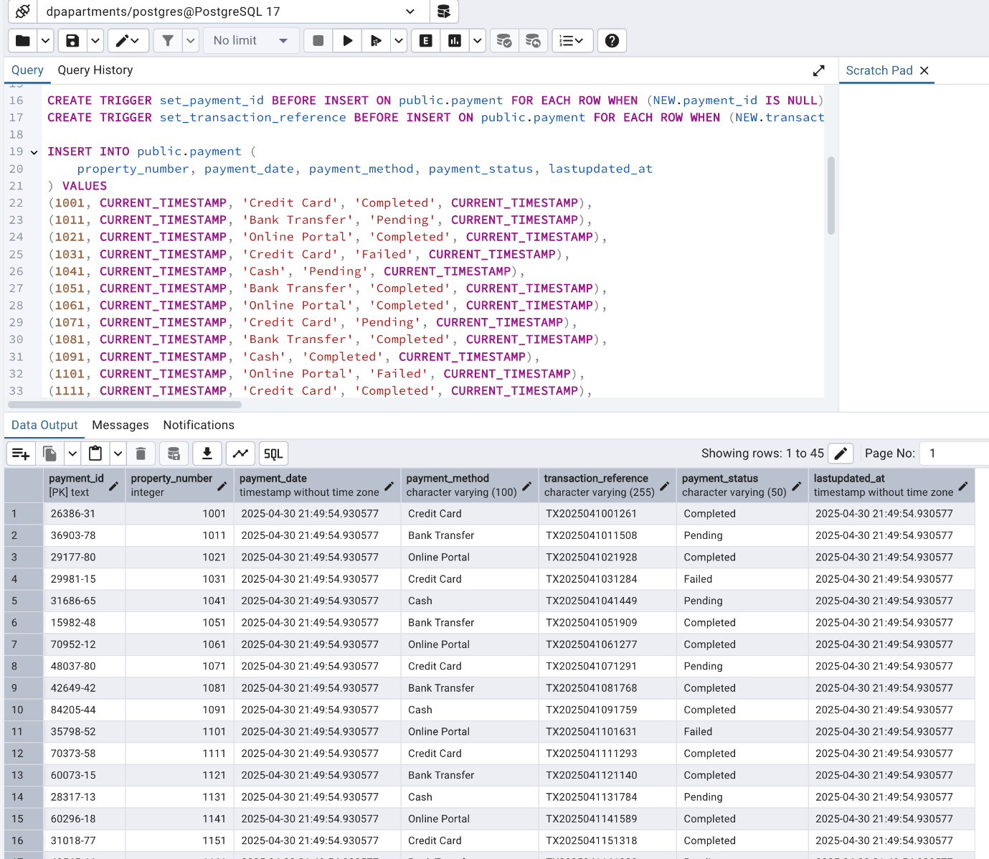

**SQL Trigger Function –** Technician

CREATE OR REPLACE FUNCTION generate_technician_id() RETURNS TRIGGER AS $$ DECLARE initials TEXT; random_part TEXT; BEGIN initials := upper( substring(NEW.technician_name, 1, 1) ||

substring(split_part(NEW.technician_name, ' ', 2), 1, 1)

); random_part := lpad((trunc(random() * 9000 + 1000)::int)::text, 4, '0'); NEW.technician_id := initials || random_part; RETURN NEW; END; $$ LANGUAGE plpgsql;

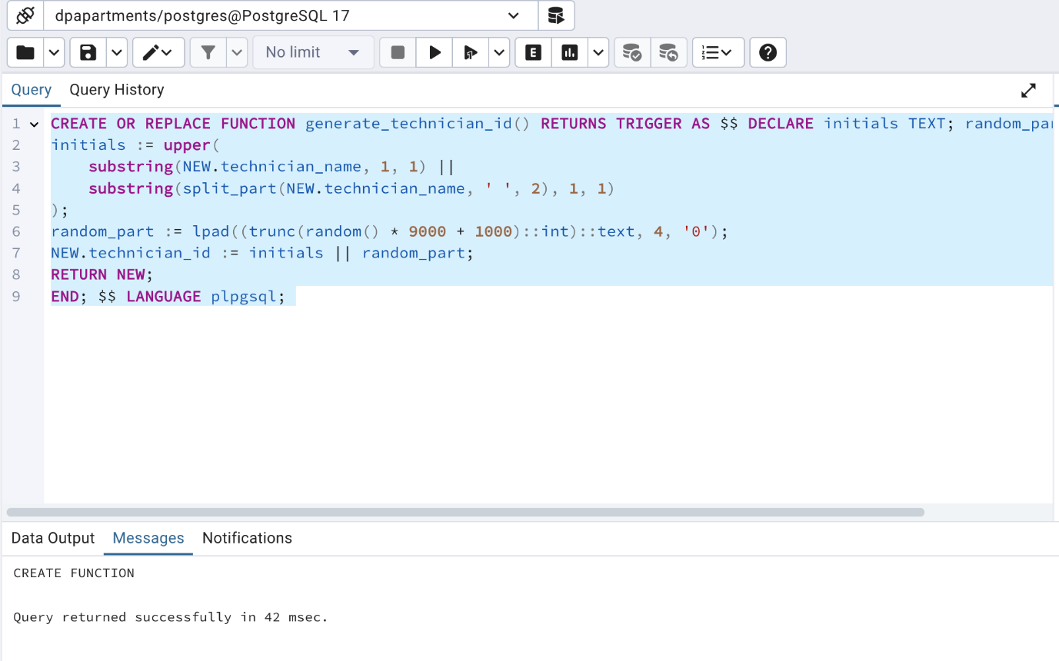

**SQL Create Table –** Technician

CREATE TABLE public.technician ( technician_id TEXT PRIMARY KEY, technician_name VARCHAR(255) NOT NULL, technician_email VARCHAR(255) UNIQUE NOT NULL, availability_status VARCHAR(50) DEFAULT 'Available', joined_at TIMESTAMP DEFAULT CURRENT_TIMESTAMP );

ALTER TABLE public.service_request ADD CONSTRAINT fk_service_request_technician FOREIGN KEY (technician_id) REFERENCES public.technician (technician_id) ON DELETE CASCADE;

CREATE TRIGGER set_technician_id BEFORE INSERT ON public.technician FOR EACH ROW WHEN (NEW.technician_id IS NULL) EXECUTE FUNCTION generate_technician_id();

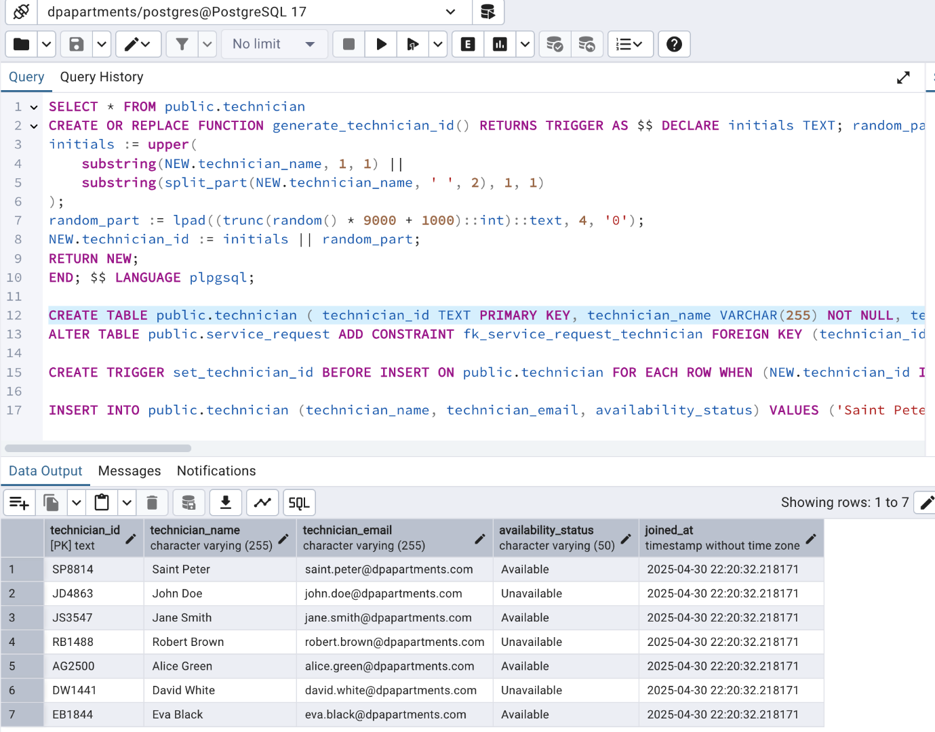

**SQL Insert Table -** Technician

INSERT INTO public.technician (technician_name, technician_email, availability_status) VALUES ('Saint Peter', '[saint.peter@dpapartments.com](mailto:saint.peter@dpapartments.com)', 'Available'), ('John Doe', '[john.doe@dpapartments.com](mailto:john.doe@dpapartments.com)', 'Unavailable'), ('Jane Smith', '[jane.smith@dpapartments.com](mailto:jane.smith@dpapartments.com)', 'Available'), ('Robert Brown', '[robert.brown@dpapartments.com](mailto:robert.brown@dpapartments.com)', 'Unavailable'), ('Alice Green', '[alice.green@dpapartments.com](mailto:alice.green@dpapartments.com)', 'Available'), ('David White', '[david.white@dpapartments.com](mailto:david.white@dpapartments.com)', 'Unavailable'), ('Eva Black', '[eva.black@dpapartments.com](mailto:eva.black@dpapartments.com)', 'Available');

**SQL Result -** Technician



**SQL Sequence Script –** Service Request

CREATE SEQUENCE service_request_sr_id_seq START WITH 1 INCREMENT BY 1 MINVALUE 1 MAXVALUE 999999 CACHE 1;

**SQL Trigger Functions –** Service Request

CREATE OR REPLACE FUNCTION generate_sr_id() RETURNS TRIGGER AS $$ DECLARE date_part TEXT; seq_part TEXT; BEGIN date_part := to_char(CURRENT_DATE, 'YYYYMMDD'); seq_part := nextval('service_request_sr_id_seq')::TEXT; NEW.sr_id := 'SR' || date_part || NEW.property_number || seq_part; RETURN NEW; END; $$ LANGUAGE plpgsql;

CREATE OR REPLACE FUNCTION assign_available_technician() RETURNS TRIGGER AS $$ BEGIN SELECT technician_id INTO NEW.technician_id FROM technician WHERE availability_status = 'Available' ORDER BY RANDOM() LIMIT 1; RETURN NEW; END; $$ LANGUAGE plpgsql;

**SQL Create Table –** Service Request

CREATE TABLE public.service_request ( sr_id TEXT PRIMARY KEY, description TEXT, img BYTEA,property_number INT NOT NULL, technician_id INT, status VARCHAR(50) DEFAULT 'Open', created_at TIMESTAMP DEFAULT CURRENT_TIMESTAMP);

CREATE TRIGGER set_sr_id BEFORE INSERT ON public.service_request FOR EACH ROW WHEN (NEW.sr_id IS NULL) EXECUTE FUNCTION generate_sr_id();

CREATE TRIGGER trigger_assign_technician BEFORE INSERT ON service_request FOR EACH ROW EXECUTE FUNCTION assign_available_technician();

**SQL Insert Table -** Service Request

INSERT INTO public.service_request ( description, img, property_number, technician_id, status, created_at ) VALUES ('Leakyibg faucet in washroom', '\xDEADBEEF', 1171, 'SP8814', 'Open', CURRENT_TIMESTAMP), ('Leaky faucet in kitchen', '\xDEADBEEF', 1171, 'JD4863', 'Open', CURRENT_TIMESTAMP), ('Bathroom light flickering', '\xDEADBEEF', 1171, 'JS3547', 'In Progress', CURRENT_TIMESTAMP), ('Front door lock jammed', '\xDEADBEEF', 1171, 'RB1488', 'Open', CURRENT_TIMESTAMP), ('Kitchen sink drainage slow', '\xDEADBEEF', 1171, 'AG2500', 'Completed', CURRENT_TIMESTAMP), ('Ceiling paint bubbling', '\xDEADBEEF', 1171, 'DW1441', 'Open', CURRENT_TIMESTAMP), ('Window crack spreading', '\xDEADBEEF', 1181, 'EB1844', 'In Progress', CURRENT_TIMESTAMP), ('Bedroom heating issue', '\xDEADBEEF', 1181, 'SP8814', 'Completed', CURRENT_TIMESTAMP), ('Thermostat malfunction', '\xDEADBEEF', 1191, 'JD4863', 'Open', CURRENT_TIMESTAMP), ('Gutter clogged', '\xDEADBEEF', 1201, 'JS3547', 'Open', CURRENT_TIMESTAMP), ('Water pooling near AC unit', '\xDEADBEEF', 1211, 'RB1488', 'In Progress', CURRENT_TIMESTAMP), ('Squeaky garage door', '\xDEADBEEF', 1221, 'AG2500', 'Completed', CURRENT_TIMESTAMP), ('Bathtub faucet leaking', '\xDEADBEEF', 1231, 'DW1441', 'Open', CURRENT_TIMESTAMP), ('Leaky Tap by the Garden', '\xDEADBEEF', 1171, 'EB1844', 'Closed', CURRENT_TIMESTAMP), ('Leaky Tap by the Garden', '\xDEADBEEF', 1171, 'SP8814', 'Closed', CURRENT_TIMESTAMP), ('Leaky Tap by the Garden', '\xDEADBEEF', 1171, 'JD4863', 'Closed', CURRENT_TIMESTAMP), ('Leaky Tap by the Garden', '\xDEADBEEF', 1171, 'JS3547', 'Open', CURRENT_TIMESTAMP), ('Leaky faucet in kitchen', '\xDEADBEEF', 1171, 'RB1488', 'Open', CURRENT_TIMESTAMP), ('Broken window in bedroom', '\xDEADBEEF', 1181, 'AG2500', 'In Progress', CURRENT_TIMESTAMP), ('AC not cooling', '\xDEADBEEF', 1191, 'DW1441', 'Completed', CURRENT_TIMESTAMP), ('Electrical outlet malfunctioning', '\xDEADBEEF', 1201, 'EB1844', 'Open', CURRENT_TIMESTAMP), ('Water heater making noise', '\xDEADBEEF', 1211, 'SP8814', 'In Progress', CURRENT_TIMESTAMP), ('Garage door stuck', '\xDEADBEEF', 1221, 'JD4863', 'Completed', CURRENT_TIMESTAMP), ('Clogged drain in bathroom', '\xDEADBEEF', 1231, 'JS3547', 'Open', CURRENT_TIMESTAMP), ('Roof leakage during rain', '\xDEADBEEF', 1241, 'RB1488', 'In Progress', CURRENT_TIMESTAMP), ('Smoke detector malfunctioning', '\xDEADBEEF', 1251, 'AG2500', 'Completed', CURRENT_TIMESTAMP), ('Broken tiles in kitchen', '\xDEADBEEF', 1261, 'DW1441', 'Open', CURRENT_TIMESTAMP), ('Backyard fence repair', '\xDEADBEEF', 1271, 'EB1844', 'In Progress', CURRENT_TIMESTAMP), ('Pest control needed', '\xDEADBEEF', 1281, 'SP8814', 'Open', CURRENT_TIMESTAMP), ('Washer not draining', '\xDEADBEEF', 1291, 'JD4863', 'Completed', CURRENT_TIMESTAMP), ('Dishwasher error code', '\xDEADBEEF', 1301, 'JS3547', 'Open', CURRENT_TIMESTAMP), ('Paint peeling in hallway', '\xDEADBEEF', 1311, 'RB1488', 'In Progress', CURRENT_TIMESTAMP);

**SQL Result -** Service Request

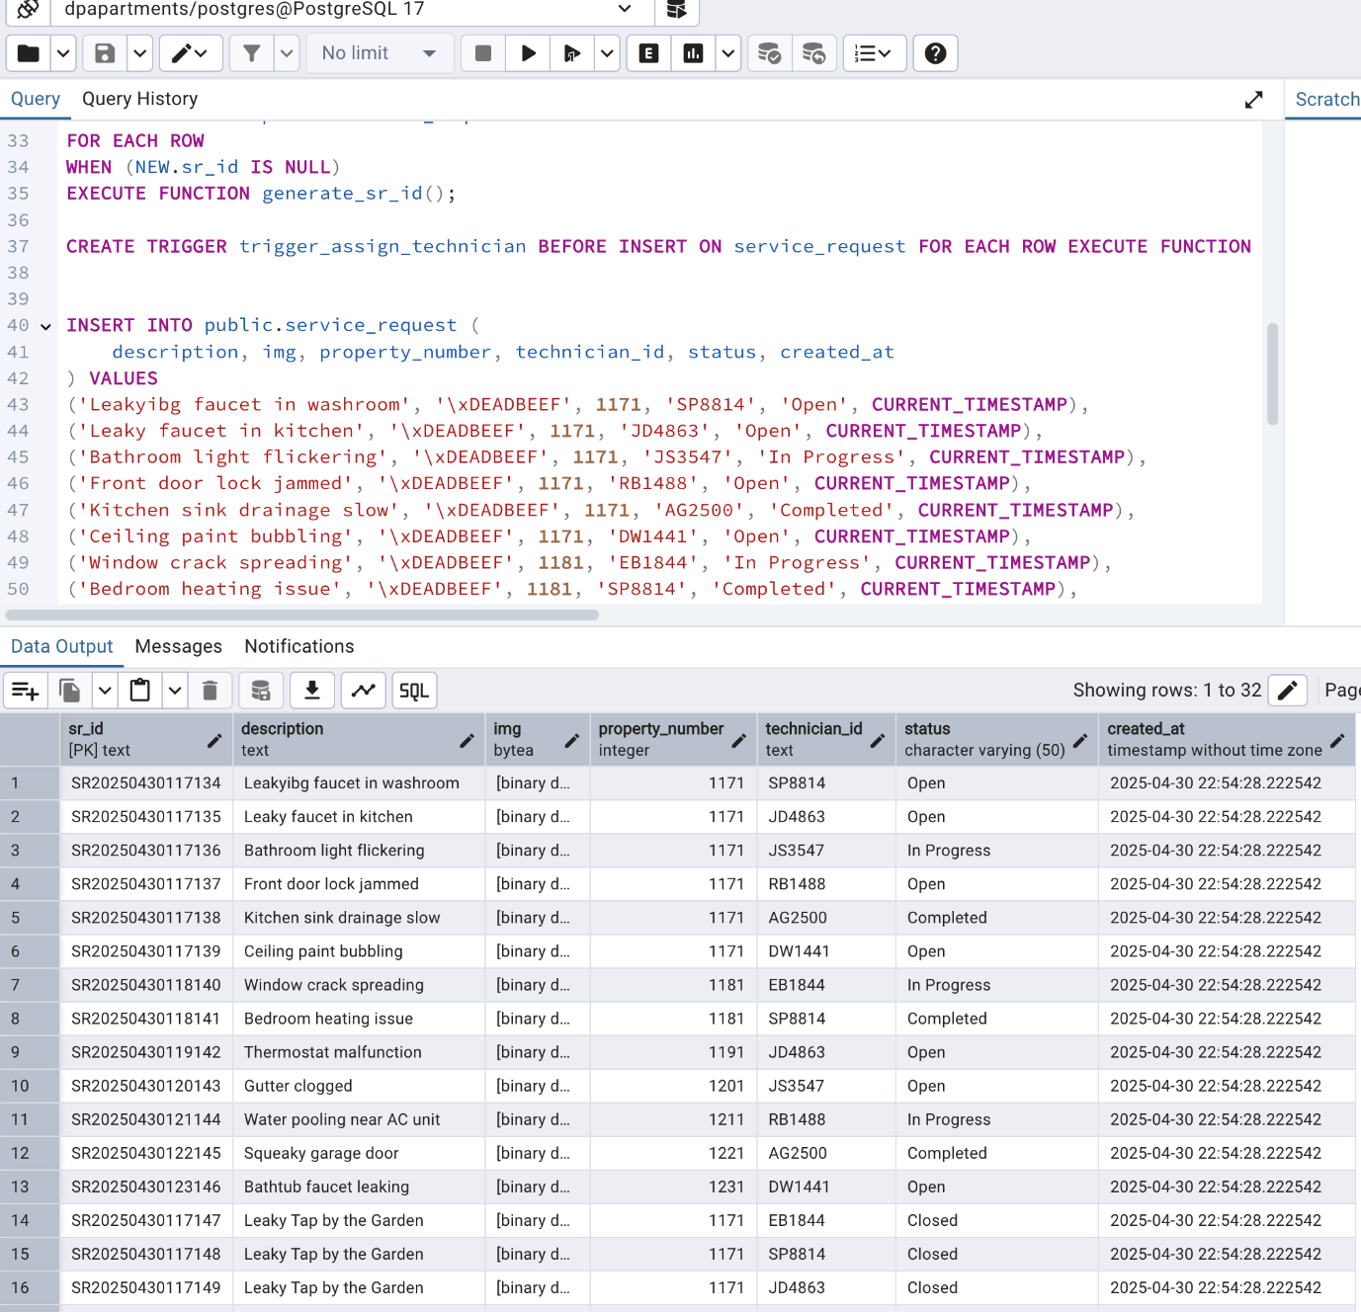

# Data Retrieval and Simple Reports:

## **Scenario –1:**

Finding properties and the respective tenants and managers with leases ending in the next month.

Query:

**SELECT** p.property_name , l.lease_end_date, t.tenant_name , t.tenant_email , m.manager_name , m.manager_email , (l.lease_end_date - CURRENT_DATE) AS days_left

**FROM** lease_file l

**JOIN** property p **ON** l.property_id = p.property_id

**JOIN** tenant t **ON** p.property_id = t.property_number

**JOIN** manager m **ON** p.property_id = m.property_number

**WHERE** l.lease_end_date >= date_trunc('month', CURRENT_DATE + INTERVAL '1 month')

**AND** l.lease_end_date < date_trunc('month', CURRENT_DATE + INTERVAL '2 months');

Result:

This query retrives all the property leases that are going to end in next month with tenant and manager information in it by joining tables , so that tenant and manager can be informed on how many days left for lease end date . A calculated field shows the days left.

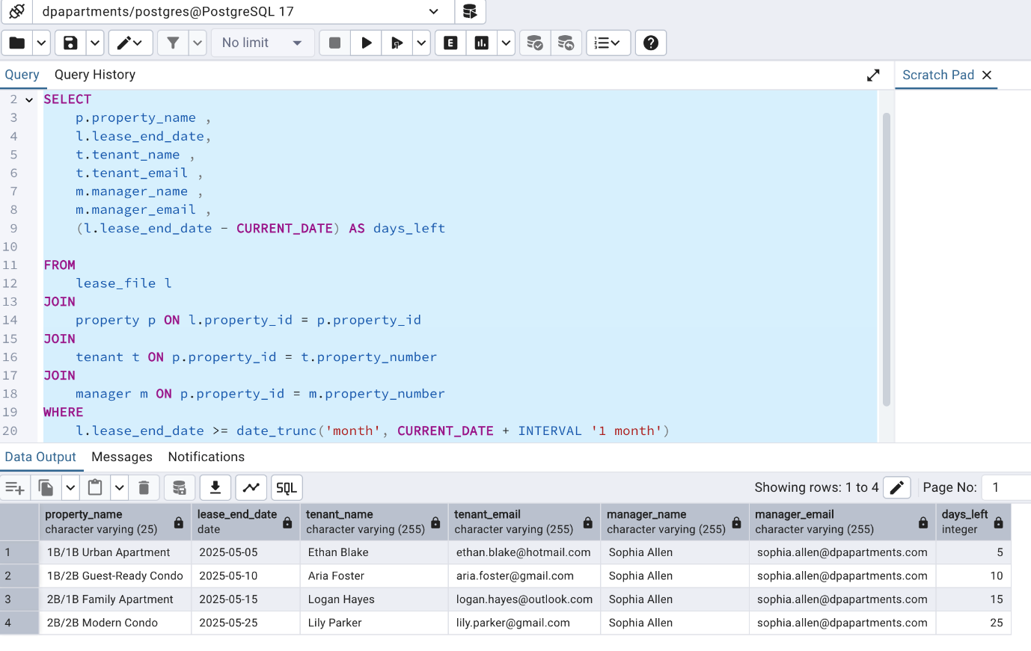

## **Scenario –2:**

Manager's current monthly Commission Calculation (5%) based upon the total rent value they manage.

Query:

**SELECT** m.manager_name, SUM(l.rent_amount) AS total_active_rent_value,(SUM(l.rent_amount) * 0.05) AS potential_commission

**FROM** manager m

**JOIN** property p **ON** m.property_number = p.property_id

**JOIN** lease_file l **ON** p.property_id = l.property_id

**JOIN** payment pm **ON** p.property_id = pm.property_number

**WHERE** DATE_TRUNC('month', pm.payment_date) = DATE_TRUNC('month', CURRENT_DATE)

**GROUP BY** m.manager_name;

Result:

This query gets the manager's current monthly Commission Calculation (5%) based upon the total rent value they manage , which means system automatically combines all the rental revenue for the current month they manage and manager gets a 5 percent in commision for the current month. Below shows the result.

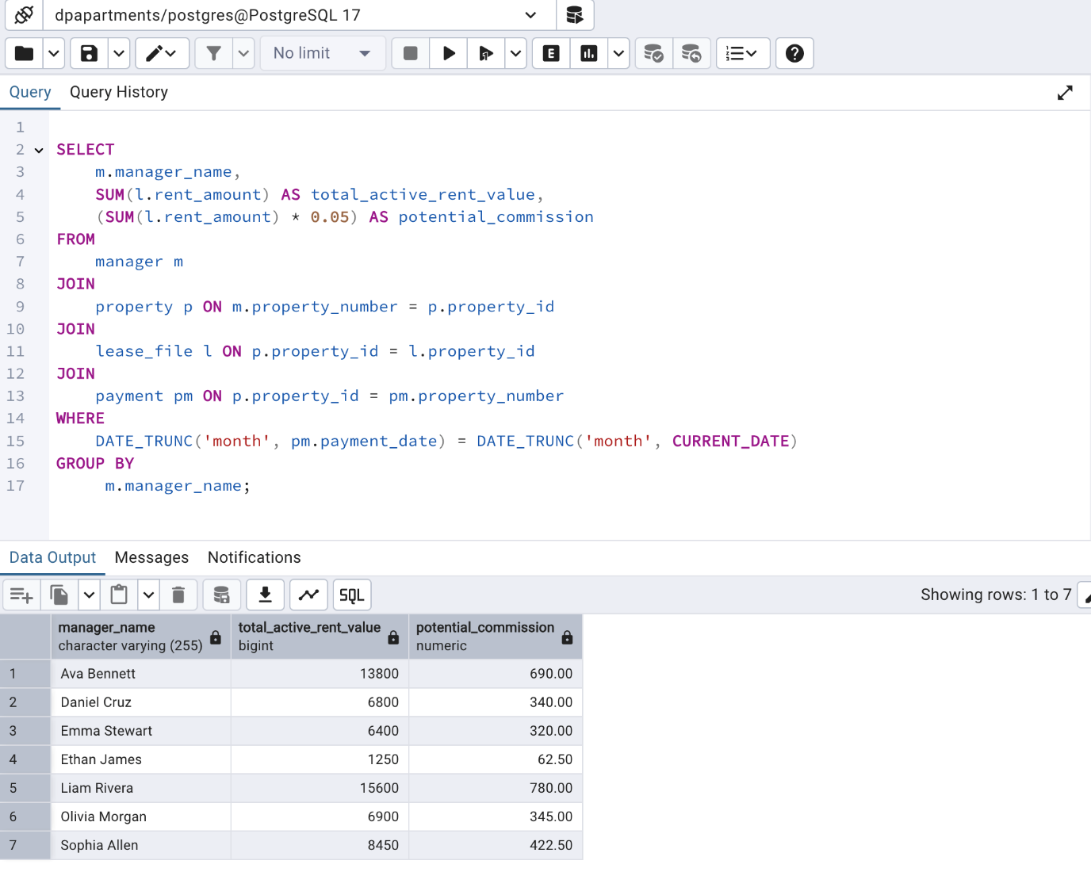

## **Scenario –3:**

Top 5 Properties by Service Requests with Owner and Tenant Details.

Query:

**SELECT** p.property_id, p.property_name, o.owner_name, t.tenant_name, COUNT (sr.sr_id) AS total_requests

**FROM** property p

**JOIN** service_request sr **ON** sr.property_number = p.property_id

**JOIN** owner o **ON** o.property_number = p.property_id

**JOIN** tenant t **ON** t.property_number = p.property_id

**GROUP BY** p.property_id, p.property_name, o.owner_name, t.tenant_name

**ORDER BY** total_requests DESC LIMIT 5;

Result:

This query gets all the top 5 Properties by Service Requests with Owner and Tenant Details so that manager or owner can have a headsup on this scenario and can take necessary actions.

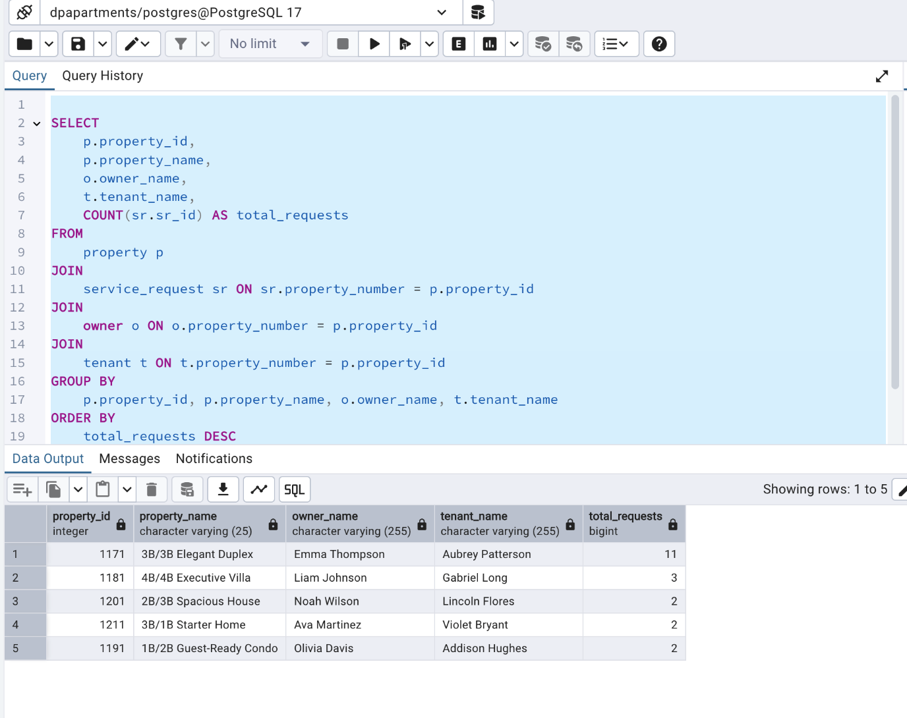

## **Scenario –4:**

Query to track all payment turnover for the current month and group the results by payment method.

Query:

**SELECT** pm.payment_method, SUM(l.rent_amount) AS total_turnover, COUNT (pm.payment_id) AS number_of_transactions

**FROM** payment pm

**JOIN** lease_file l **ON** l.property_id = pm.property_number

**WHERE** pm.payment_date >= date_trunc('month',CURRENT_DATE) AND pm.payment_date <= date_trunc('month',CURRENT_DATE)+INTERVAL '1 month'

**GROUP BY** pm.payment_method

**ORDER BY** total_turnover DESC;

Result:

This query helps to track all payment turnover for the current month and group the results by payment method so that the management can track on the payment method , if it is cash hence they can add more work force accordingly to collect payments.

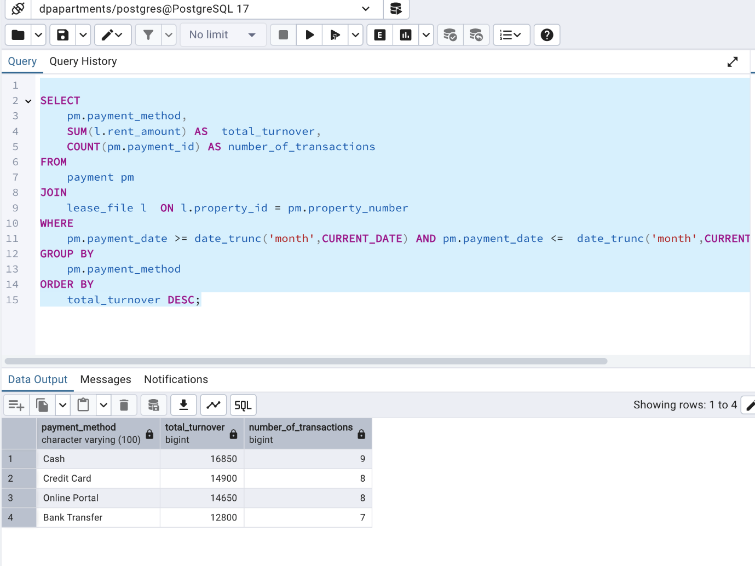

## **Scenario – 5:**

List of properties that Vacant with manager contact information.

Query:

**SELECT** p.property_id, p.property_name, p.property_type, p.property_description, p.property_image, 'Vacant' AS tenant_status

**FROM** property p

**LEFT JOIN** tenant t **ON** t.property_number = p.property_id

**WHERE** t.tenant_name IS NULL

**ORDER BY** p.property_id DESC;

Result:

This query gives all the list of properties that Vacant with manager contact information when a tennat searches for a new property on the website this shows up all the properties without nay tenants assigned which menas they are vacant and ready to occupy.

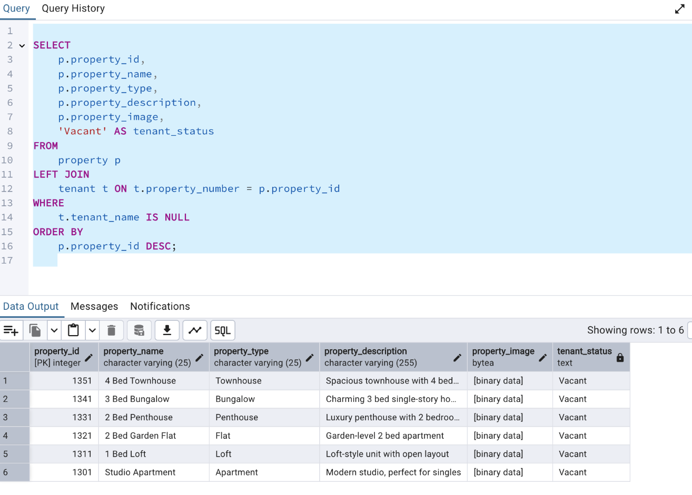

**AI use disclosure statement:**

We acknowledge the use of Gemini (<https://gemini.google.com/app/c45d9c1c10508825> populate our data with syntheic records . The tool was used to provide columns with syntheic data for the attribute . The output from this tool was used populate our data with syntheic records for all our tables .